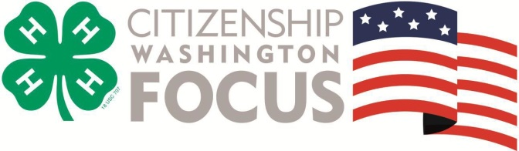
What?

- Thousands of young people from across America come to the National 4-H Youth Conference Center every summer to participate in CWF, a citizenship and leadership program held in Washington, DC. Through a series of speakers, committee work, field trips and social events, participants learn the importance of citizenship and social responsibility and are given the opportunity to explore, develop, and refine skills needed to be an outstanding leader on both a local and national level.

Why?

- Impact and action planning – Our focus is life-long civic engagement, and delegates leave with a plan of action to tackle issues facing their own communities when they return home.
What Are Others Saying?

“CWF has been the highlight of my 4-H Career.”
-- Oklahoma Delegate

“I didn't have the faintest idea what a good citizen was before I came here, and now I know it's what I strive to be.”
-- Colorado Delegate

“What I enjoyed the most about CWF was the fact that I got to interact with people from different communities with different backgrounds than my own.”
-- Ohio Delegate

“There is one word for this trip... AWESOME.”
-- Colorado Delegate
- Living classroom of Washington, DC – Collegiate Program Assistants, serving as facilitators, tour guides and role models immerse delegates in the culture and history of our country through onsite discussions at DC’s most spectacular locations. Destinations include: The Capitol Building, Mount Vernon, Arlington National Cemetery, presidential and war monuments and memorials, Smithsonian museums and more.
- More than just monuments – CWF isn’t just another sightseeing trip to Washington DC. Through hands-on educational workshops, youth learn about the history of our nation, and the leaders who shaped it.
- Diversity, friendship and fun – CWF is a once in a lifetime opportunity to exchange ideas, practice respect, form friendships and share experiences with those from all across the country.
- Exclusively 4-H focused – CWF is a 4-H tradition that dates back more than 50 years, and is the only such national citizenship and leadership program offered exclusively to 4-H members.

Who?
- 45 Michigan 4-H Youth ages 14-19

When?
- June 23-30, 2018. The Michigan delegation leaves on Saturday, June 24 and will drive the first day to Gettysburg, PA. On Sunday we tour the battlegrounds before finishing our travel to DC.

Where?
- National 4-H Youth Conference Center, Chevy Chase, MD; one mile from Washington D.C.

How Much?
- Total cost is $1450 (includes transportation, lodging in both Gettysburg and Chevy Chase, conference costs, and most meals).
- Registration does not include the cost of 6 meals or spending money.
- Non-refundable deposit of $500 is due on December 27, 2018.

For Questions or More Information:
Visit the CWF website: http://www.4hcwf.org/ or contact the Michigan coordinator: Connie Lange, langec@anr.msu.edu, 517-279-4311

MSU is an affirmative-action, equal-opportunity employer, committed to achieving excellence through a diverse workforce and inclusive culture that encourages all people to reach their full potential. Michigan State University Extension programs and materials are open to all without regard to race, color, national origin, gender, gender identity, religion, age, height, weight, disability, political beliefs, sexual orientation, marital status, family status or veteran status. Persons with disabilities have the right to request and receive reasonable accommodations.
Accommodations for persons with disabilities may be requested by contacting <insert name of office contact> at <insert telephone number> by <insert date> to make arrangements. Requests received after this date will be fulfilled when possible. (Please allow no less than one week for short programs and no less than one month for overnight programs.)

