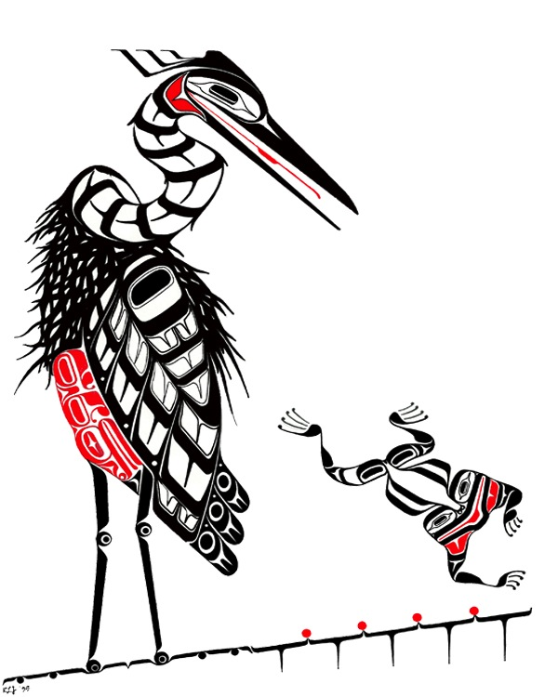Heronswood Garden Horticultural Internship Program

Summer 2018

Heronswood Garden Horticultural Internships provide candidates the opportunity to expand their horticultural and plant identification knowledge, improve their gardening skills and use of horticultural tools and equipment, and develop their professional network. Interns work under the direction of Garden Director Dan Hinkley and alongside highly experienced professional gardeners in a working botanical garden.

The Heronswood Internship Program originally began in 1993. Heronswood Garden Interns have gone on to hold positions of prominence across the United States.
Now under the ownership of the Port Gamble S’Klallam Tribe and the management of the tribe’s Foundation, the Internship Program was re-launched in 2015. Internships run a minimum of three months, includes free accommodations at the Garden, and the compensation reflects Washington State minimum wage. We will work with a candidate’s school calendar as needed.
Applicants must be able to do physical labor outdoors, possess a valid driver's license, and be available to work the full term of their internship, including some weekend shifts. Hours are 8:00am to 4:30pm. After hours academic research is a required component of the program.
Work activities include:
- General maintenance; weeding, pruning, fertilizing, and trail upkeep.
- Stewardship of a specific garden area, including development of plant palettes (with some supervision) and planting design for these areas.
- Soil preparation; planting and transplanting. Mulching.
- Comprehending the Heronswood Garden plant inventory system and aiding in verification and updating of the garden database.
- Assistance with public Garden Open events on an ‘as assigned’ basis.
- Assistance with volunteers on Weed, Walk and Talk events and other garden volunteer activities.
- Propagation and potting on a limited basis.
- Willingness to work independently and with a team, in adverse weather conditions, and some weekend hours. Able to life 50 lbs.

Research and expansion of plant knowledge:
- Weekly plant identification and research assignments to build the Intern’s knowledge of taxonomy and key identifying characteristics of the plants.
- Assignment to an area of the garden to develop an intimate knowledge of and work with the staff in reworking the bed’s design for the betterment of the garden.

HERONSWOOD GARDEN
2018 HORTICULTURAL SUMMER INTERNSHIP PROGRAM
APPLICATION FORM

To be considered for a Heronswood Internship, submit your signed and completed application form along with a cover letter, résumé and references form by February 28, 2018. Late or incomplete application packages will not be considered.
Full Name: _____________________________________________________________________

Permanent Address: _____________________________________________________________

______________________________________________________________________________

Permanent Telephone Number: ____________________________________________________

Email Address: __________________________________________________________________

Are you requesting that your school provide you with credit hours for your internship? If yes, please provide needed paperwork from your school.

School: ________________________________________________________________________

School Contact: _________________________________________________________________

School Phone: __________________________________________________________________

Education and relevant experience: Provide of copy of your academic transcripts.

Are you legally eligible to work in the United States? □ Yes □ No
If you are not a U.S. Citizen, are there any restrictions on your eligibility for employment? □ Yes □ No

Dates available for internship: From_____________________ until ________________________
The internship runs a minimum of three months. We will work with a candidate’s school calendar as needed.
Signature: ______________________________________________________________________
REFERENCES

Please provide the names and contact information for three individuals familiar with your academic and work experience relevant to a horticultural internship.

Reference 1

Name: _________________________________________________________________________

Address: _______________________________________________________________________

Email: _________________________ Phone/s: ______________________________________

Relationship to Applicant: _________________________________________________________

Reference 2

Name: _________________________________________________________________________

Address: _______________________________________________________________________

Email: _________________________ Phone/s: ______________________________________

Relationship to Applicant: _________________________________________________________

Reference 3

Name: _________________________________________________________________________

Address: _______________________________________________________________________

Email: _________________________ Phone/s: ______________________________________

Relationship to Applicant: _________________________________________________________

Submit your: (1) signed application form, (2) cover letter clearly stating your relevant experience and your interest in the Internship Program, (3) résumé, and (4) references form by February 28, 2018 to:

Heronswood Garden Internship Program
c/o Port Gamble S’Klallam Foundation
31912 Little Boston Road
Kingston, WA 98346

