Editing Approved Enrollments
Before You Start
Managers can edit/modify approved enrollments with some restrictions.
- Areas of submitted enrollments that could increase a member’s fees cannot be changed.
- The member’s grade cannot be changed if it would result in changing the member’s role. System Admins should submit a request to the Support Team for edits that would change the member’s role.
Steps  - To edit a member’s approved enrollment, click on the Enrollments tab in the navigation pane.  - On the “Approved” sub-tab, search for the member’s name and click on the record. | Screenshots  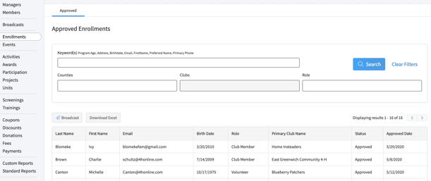  (Screen appearance may vary per state)
- Click the edit button next to the category to be edited (Clubs, Projects, Demographics, Other Questions and Files).  - Add additional clubs, add projects, and edit demographic and custom question responses as needed.  - Click Save to save the changes to that section. | 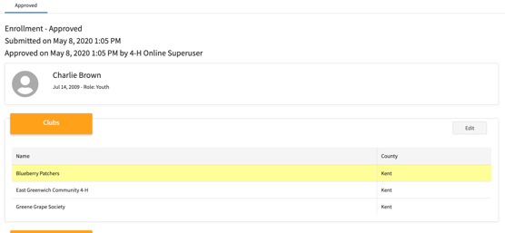
- Managers are also able to upload or replace files that were uploaded during the enrollment process. Click Edit on the file.  - If a file has not previously been uploaded, click the Upload button.  - If a file has previously been uploaded, select the appropriate option as follows:  - Overwrite to replace the file  - Download to download and save the file Delete to remove the file from the member’s enrollment | 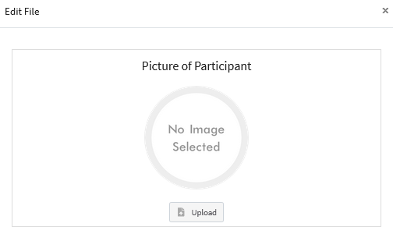  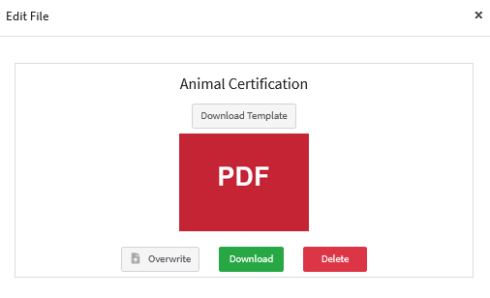
Tips
- If an adult volunteer did not select a Club Volunteer type, the club selection section will not be available. First add the appropriate Club Volunteer type to the approved enrollment before you can select the appropriate club(s).
- If an adult volunteer did not select a Project Volunteer type, the project selection section will not be available. First add the appropriate Project Volunteer type to the approved enrollment before adding project(s).

