Health and Nutrition Institute
Nutrition and Physical Activity Workgroup

2013 WIC Project Fresh
State Wide Evaluation Report

Submitted by: Olga J. Santiago Rivera, PhD., Shayna Danto & Pat Benton, RD.
November 6, 2013
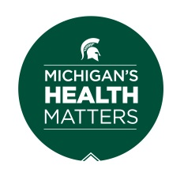

This material was funded by USDA's Supplemental Nutrition Assistance Program -- SNAP. The Supplemental Nutrition Assistance Program (SNAP) provides nutrition assistance to people with low income. It can help you buy nutritious foods for a better diet. To find out more, contact your local DHS office. MSU is an affirmative-action, equal-opportunity employer. Michigan State University Extension programs and materials are open to all without regard to race, color, national origin, gender, gender identity, religion, age, height, weight, disability, political beliefs, sexual orientation, marital status, family status or veteran status.

2013 WIC Project Fresh Evaluation

1. Project Goal and Background
Goal: To create awareness of the nutritional benefits of fruits and vegetables, thereby increasing consumption.
Core nutrition message:
- Eat the recommended servings of fruits and vegetables daily (2 ½ to 3 cups).
Participants will be able to:
- Discuss the benefits of eating various fruits and vegetables.
- Identify ways to incorporate more fruits and vegetables into their diets.
Background:
Many Americans do not consume the recommended amount of fruits and vegetables. Eating the recommended amounts can help reduce risk for certain cancers, heart disease, diabetes, high blood pressure, and help maintain a healthy weight. Both fruits and vegetables are high in vitamins, minerals, and fiber. Eating a variety is very important in order to get all necessary nutrients.
WIC Project Fresh provides coupons to purchase fresh fruits and vegetables at farmer markets. 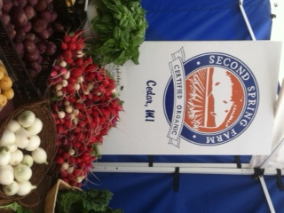
What is Project FRESH?
- Project FRESH is an educational program providing participants with coupons to purchase locally grown fresh fruits and vegetables at participating farmers’ markets.
- It plays an important role in helping families eat more fruits and vegetables.
- It also benefits local farmers by providing them with additional income through the redemption of the Project FRESH coupons.

2. Progress in Achieving Goal(s)

During 2013, WIC Project Fresh has been offered to more than 8,900 participants throughout the state of Michigan. In the following section we present a summary of the findings from WIC 2013 Project Fresh data for all counties in Michigan. This data is based on evaluation forms that were collected by the instructors and reported to the MSUE Health and Nutrition Institute, Nutrition and Physical Activity Workgroup Evaluation office (as of October 30, 2013).
  - Socio-demographic characteristics

The MSUE instructors reported that the WIC Project Fresh lessons have been provided in 74 counties in Michigan: Alcona, Alger, Bay, Benzie, Berrien, Branch, Calhoun, Cass, Charlevoix, Cheboygan, Chippewa, Clare, Clinton, Crawford, Delta, Dickinson, Eaton, Emmet, Genesee, Gladwin, Grand Traverse, Gratiot, Allegan, Hillsdale, Huron, Ingham, Iosco, Iron, Isabella, Jackson, Kalamazoo, Alpena, Kalkaska, Kent, Lake, Lapeer, Leelanau, Lenawee, Livingston, Luce, Antrim, Mackinaw, Macomb, Manistee, Mason, Mecosta, Midland, Missaukee, Monroe, Montcalm, Montmorency, Arenac, Muskegon, Newaygo, Oakland, Oceana, Ogemaw, Osceola, Otsego, Ottawa, Presque Isle, Roscommon, Saginaw, Sanilac, Shiawassee, St. Joseph, Tuscola, Barry, Van Buren,Washtenaw, Wayne, and Wexford.
In Michigan, during Summer 2013 WIC Project Fresh was delivered in 74 counties, to 556 groups (June to October). A total of 8,979 participants received the nutrition education from MSUE instructors and completed the evaluation form. 92% of the participants were women. Of those who reported their ethnicity 13% were Hispanics, and 87% were Non-Hispanics. In terms of race 13% were African American; 70% White; and 6% selected others races.
WIC Project Fresh can be the first experience in a Farmer Market 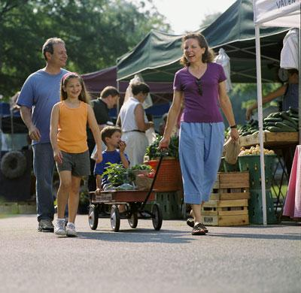
2.2. Visits to farmer’s markets
Project Fresh can be the first farmers’ market experience for many WIC participants; 16% of the participants reported that they haven’t been to a farmers’ market before. Based on the participants’ answers, as a result of attending the MSUE presentation workshop, 95% of the participants indicated they intended to buy fruits and vegetables at the local farmer’s’ market.
2.3 Participation in Project Fresh and Redemption of coupons
Participants reported their participation in Project Fresh during the last year, and their experiences redeeming their coupons. Fifty four (54%) of the participants reported that they did not participated in Project Fresh last year.

Of those that participated in Project Fresh last year, 88% reported that they used ALL their coupons last year, and 22% reported that they did not use all of them.
88% of the participants used ALL of their coupons last year. 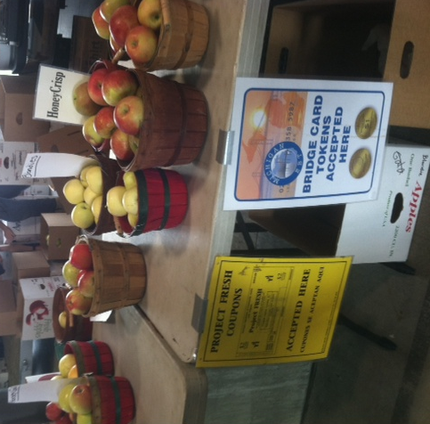

We asked those that did not redeem all of their coupons to provide reasons for it. A total of 428 participants answered to this question. They selected one or more reasons. The most frequent reasons were:
- No time (20%)
- Working (19%)
- Hours of the market (18%)
- No transportation (16%)
- Poor selection of fruit and vegetables (12%)
- No market (4%)
- Lost coupons (4%)
Note: number in parenthesis represents the percent of the 428 participants that selected the alternative.
2.4. Intentions of healthy behaviors as a result of attending the WIC Project Fresh presentation

Education to WIC participants through Project Fresh can create awareness of the importance of eating fruits and vegetables. Participants indicated that as a result of attending the MSUE food presentation workshop...

- 93% will eat more fresh vegetables a day.

- 93% will eat more fresh fruits per day.

2.5 Concepts learned, and awareness of the potential benefits of a healthy diet.
  - As a result of attending the MSUE food presentation workshop...

- 89% of the participants learned new ways to incorporate more fruits into their meals and snacks.
WIC Project Fresh creates awareness of the benefits of eating fruits and vegetables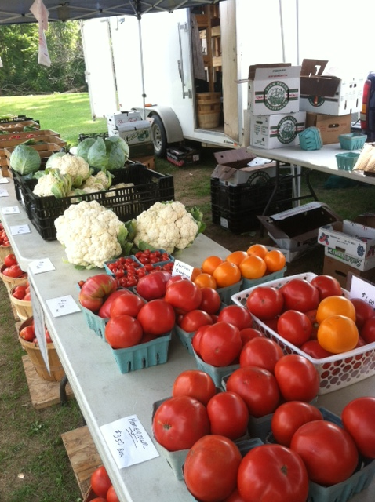

- 89% of the participants learned new ways to incorporate more vegetables into their meals.

- 98% of the participants agree or strongly agree with the statement “Eating fruits and vegetables everyday as part of a healthy diet may reduce your risk of certain types of cancer and various diseases.”

3. Overall Assessment

We were able to reach a significant number of participants with WIC Project Fresh nutrition education program. Specifically, those participants from whom we were able to gather outcome data voiced intentions to improve healthy behaviors and to buy fresh fruits and vegetables at their local farmers’ market as a result of attending the WIC Project Fresh presentation.

