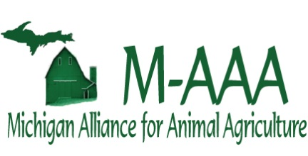
Cover Page (2017 Funding)

Project Title: Click here to enter text.
Principal Investigator: Click here to enter text.

Collaborators: Click here to enter text.
Campus Mailing Address: Click here to enter text.
Email: Click here to enter text.
Phone #: Click here to enter text.
Umbrella Project/MICL#: Click here to enter text.

Program Area (check one) | Money & Duration of Project
Applied Research ☐ | Total Duration of Project: Click here to enter text.
Extension ☐ | $$ Requested FY17 Only: Click here to enter text.
Seed Funding ☐ | Total Funds requested: Click here to enter text.

Proposal Summary (limit to 250 words):

Budget Form (2017 Funding)
Project Title:

Michigan Alliance for Animal Agriculture Funding Requested
Budget Item | FY17 Request | FY18 Request | Matching Funds Committed* | In-Kind  Contributions*
Personnel Wages
A1. Research associates & post-docs
A2. Technical/Administrative Support
A3. Other
A4. Fringe Benefits**
(Must be charged as direct costs.)
B. Graduate students – including fringes***
C. Undergraduate students****
Subtotal A+B+C #1
D. Materials, Supplies & Publications
E. Travel
Subtotal D+E #2
Grand Total #1 + #2

* Identify sources, amounts and status of non-M-AAA funds. Informational only, this will not be tracked by CGA/OSP
** Use MSU Contracts and Grants Web site to calculate fringe rate for MSU personnel
*** List graduate student costs as a lump sum
**** Fringe benefits are not charged to wages for MSU undergraduate students.

Matching Funds (Including In-Kind) Section: Use additional sheet if necessary

Source | Amount

