Courses –

Additions, Changes, Deletions

# College of Agriculture and Natural Resources Guidelines

## Background information:

1. More information and instructions are available on the Registrar’s Office website at <https://reg.msu.edu/ucc/guidelines.aspx>.
2. All requests for new, changed or deleted courses are submitted to University Curriculum and Catalog using the [Office of the Registrar (RO) Online Forms Menu](https://reg.msu.edu/Forms/FormsMenu.aspx) (https://reg.msu.edu/Forms/FormsMenu.aspx).
3. Curricular changes may be effective for any semester – fall, spring, or summer session.
4. When planning an effective date, the following questions should be considered:
   1. Does the request have funding implications? If so, the request requires unit reflection for budget projections and planning, and must follow normal administrative channels.
   2. Are there any academic policy implications?
   3. Does the request involve teacher certification?
   4. Are approvals/signoffs required?

## College Process:

1. Plan your new course or course changes by working with departmental faculty and committees, department chair, college associate dean and any other affected units (departments and/or colleges) that may have an interest or conflict with the proposed changes. Communicating with affected units in advance will make the approval process much easier.
2. Access the Registrar’s Office [online form system](https://reg.msu.edu/Forms/FormsMenu.aspx) (<https://reg.msu.edu/Forms/FormsMenu.aspx>) and log in.
3. Click on [COURSES: Course Request System](https://reg.msu.edu/Forms/Courses/CoursesMenu.aspx) (https://reg.msu.edu/Forms/Courses/CoursesMenu.aspx). There is a blank course request form in Word and PDF format that you can use for planning purposes (see page 4). The formal request **must** be done in the online form.
4. Add or make changes to the appropriate course or program, completing all required sections. See the [Instructions page](https://reg.msu.edu/Forms/Courses/help.aspx?HType=main) (<https://reg.msu.edu/Forms/Courses/help.aspx?HType=main>) on the Registrar’s Office website (see link on page 4) or the additional help section below for line by line instructions. Please note:

* After completing a page of the form, advancing to any other page will save entries on the current page.
* Most items on the course request form require information. For those items that are not applicable to the request, the box(es) must be left blank. Do not enter "None" or other terms in a box. If an item is not applicable but the form will not let you proceed without entering something in the box, type a space.

1. Save your new or changed course.

*Helpful Hint*: Kelly Millenbah is willing to review requests before the request is submitted to the College Curriculum Committee (CCC) to provide suggestions for changes or improvement.

1. ***Please* do NOT** **submit or approve the form yet**. If you submit the form, the electronic approval process starts and the department cannot access the form for changes of any type, including CCC-required changes. Wait until CCC has reviewed the course and provides feedback. If CCC requires changes, you will need to make the changes. If you approve the form before CCC review and changes are required, you will have to start with a new form to initiate a new electronic approval process, which can confuse other units that have already been asked to review, comment and approve the course request.
2. Send an email to [CANR.CCC@anr.msu.edu](mailto:CANR.CCC@anr.msu.edu) with a request to put the course on the agenda for the next CANR CCC meeting. **Agenda items are due one week and one day before a CCC meeting is scheduled.**

*Helpful Hint*: The committee meets every other week during the academic year. A departmental representative is **required** to attend the meeting when the CCC reviews the request for new or changed courses or programs to answer any questions. The unit representative is responsible for conveying required changes from the CCC to the unit so they can be made in a timely manner.

1. The department will be notified by OASA staff within 3 days after the CCC meeting of changes requested by the CCC and/or request approval. The unit representative at the meeting is expected to follow up with the unit’s chair/director, faculty and staff to facilitate the changes to the course request.
2. If required, make requested changes by going to the third section of the COURSES Menu and selecting “Change” a Pending Request.

*Helpful Hint*: If you submitted the form for approval by mistake, you may use the “Change” a Pending Request form, but you will be asked to resubmit the necessary approvals so the changes can be re-routed to the appropriate units.

1. After any requested CCC corrections are made, proceed to Signoff and Approvals and approve at the Department Level (no further edits can be made once approved so be sure you have completed everything).

## Next Steps:

1. After approval by originating department and college, if appropriate, notices will then be sent to other departments or schools or colleges for additional approvals or review, sign off, and comment.

*Helpful Hint*: If you communicate in advance with other affected units that may have an interest in the course, like when you are in the planning stages, this step will be accomplished much more quickly. (See Step 1 under College Process.)

1. A notice will then be sent to University Curriculum and Catalog indicating that the request for the new course is available for interim approval and for action by a University Committee on Curriculum (UCC) Subcommittee. The request will not be available for action by a UCC Subcommittee until all of the necessary approvals have been received (see Next Steps, #1).
2. A UCC Subcommittee will take the request under review and forward their recommendation to the UCC Full Committee for action. A unit representative **may be requested** to attend either the UCC Subcommittee meeting and/or the UCC Full Committee meeting by UCC staff or the CANR Associate Dean, if it is determined that a representative would be helpful in explaining the changes to committee members and facilitating passage of the request.
3. The request is forwarded to Faculty Senate for review and approval.
4. Any notifications of approval or denial of curriculum requests received by OASA staff from Academic Governance will be forwarded to the department in a timely manner.

# Special Notes and Instructions

## To request a new course.

In addition to the instructions above, please see the notes below.

1. A syllabus for the course must be submitted to [canr.ccc@anr.msu.edu](mailto:canr.ccc@anr.msu.edu) with the request to place the **NEW** course request on the next CCC meeting agenda.
2. When a syllabus is submitted with a new course request form, there must be consistency between the syllabus and the New Course Request Form. Please make sure there are no contradictions between the documents.

## To request a change in the course number.

1. In the second box on the COURSES menu page, click on “Change” an Approved Course.
2. Choose item number 3 to change the course number.
3. Send your request for CCC to review and approve your change to [canr.ccc@anr.msu.edu](mailto:canr.ccc@anr.msu.edu).
4. Be prepared to attend or send a representative to a CCC meeting.

## To request a change in the semester offered.

1. In the second box on the COURSES menu page, click on “Change” an Approved Course.
2. Choose item number 8 to change the semester offered.
3. Send your request for CCC to review and approve your change to [canr.ccc@anr.msu.edu](mailto:canr.ccc@anr.msu.edu).
4. Be prepared to attend or send a representative to a CCC meeting.

## To delete an existing course.

Use the delete form found under the COURSES menu, the Approved Course sub-menu.

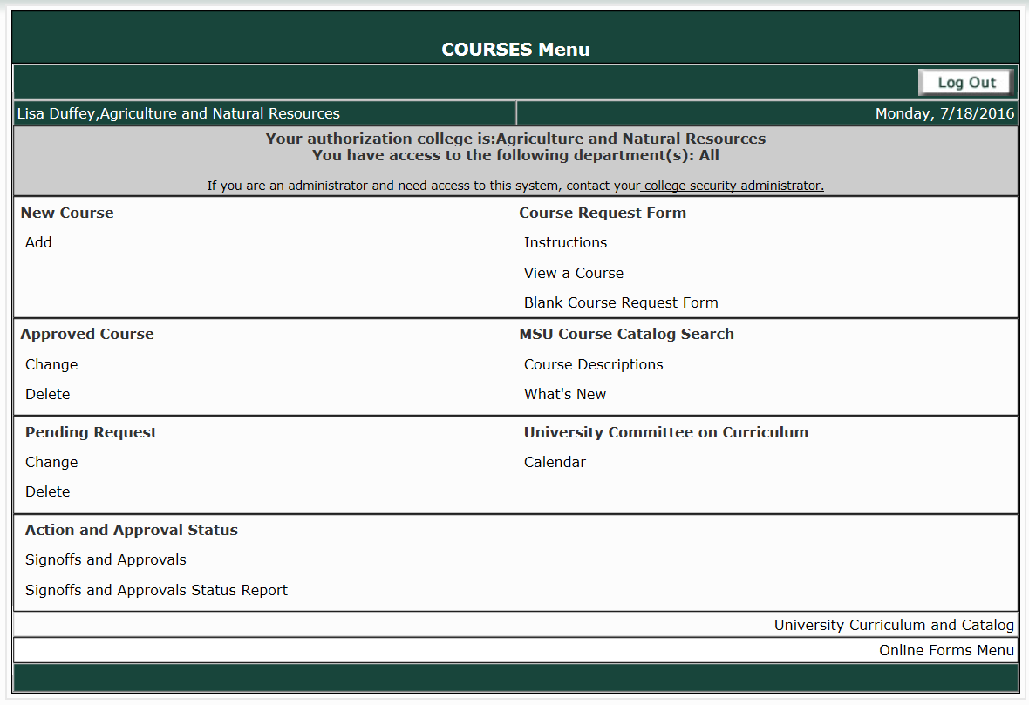

# Line by Line Suggestions for the Course Request Form

[Registrar’s Office Instructions](https://reg.msu.edu/Forms/Courses/help.aspx?HType=main): (https://reg.msu.edu/Forms/Courses/help.aspx?HType=main)

* After completing a page of the form, advancing to any other page will save entries on the current page.
* Most items on the course request form require information. For those items that are not applicable to the request, the box(es) must be left blank. Please do not enter “NA” or “None” in a box.

COURSE REQUEST FORM

Michigan State University

Office of the Provost

This form must be completed in accordance with the Instructions for Completing the Course Request Form.

DATE:

NOTE: "*" identifies information that is subject to approval by University‑level academic governance. Most of this information will be included in the *Descriptions of Courses* publication upon approval.

1. General Reason: As briefly as possible, indicate the reason for the request.

Example 1: Change course title; update topics, description and recommended background.

Example 2: New online soils course for Agricultural Technology students.

Example 3: Add new course that integrates research methods, ethics and scholarship.

Example 4: Reduce credits, modify content and remove the tier II writing designator.

*2. Course Subject Code: This is the code for your department.

*3. Course Number: The number of the course for which you are requesting an addition, a change or a deletion. See the Course Numbers policy in Academic Programs at: <http://www.reg.msu.edu/AcademicPrograms/Text.asp?Section=112#s502>

*4. Course Title: The title of the course as descriptive as possible in the briefest possible way.

SIS/Transcript Title: An abbreviation of the course title to fit in SIS and on the student’s transcript. The character limit is 30. Use capital and lower case letters. Abbreviations and acronyms and ampersands are acceptable. The short title will appear in the Schedule of Courses and on students' academic records, including transcripts.

*5. Catalog Course Description: The description of the course that will tell the student what they may expect to learn in the course. If the course is online or requires field trips, this should be indicated in the description. Incomplete sentences are acceptable; avoid unnecessary phrases.

Example 1: Soil and its impact on plant growth, plant and water relations, drainage, nutrients, soil as a resource, and erosion control techniques. This is an online course.

Example 2: Turfgrass identification. Site analysis and recommendations. On campus facility and venue visits. Mowing equipment and practices. Turf establishment. Soil cultivation and amendments. Fertilizer and pest management. Field trips required.

Example 3: Determination of the environmental footprint of products, packages and systems during their entire life-cycle using life cycle assessment (LCA) methodology. Introduction to the theory and application of LCA.

*6. Interdepartmental Course(s):

List by course subject code all of the participating units as appropriate.

a) _____b) _____c) _____d) _____e) _____f) _____

An interdepartmental course must be administered by more than one department or school or college. However, on a case-by-case basis, the UCC will consider exceptions that involve course subject codes within a given department. The interdepartmental status of a course will be reflected in the Course Descriptions.

7. This request should be processed at the same time as the following related academic request(s): If this course request is part of an academic program change, please indicate that in this section.

This request should be processed at the same time as the following related course request(s): If this course request is contingent upon or influences another course request, please indicate that in this section.

If a course is replacing an existing course or a course number change is requested, a request to delete the existing course must be submitted at the same time, but with a separate request form.

*8. Semester and off campus site: Enter when the course will formally be offered and how many students are expected to enroll in the course at each offering. Only if the course is only offered at an off-site location, indicate the location.

|  |  |  |
| --- | --- | --- |
| Frequency: | Expected Enrollment: | Off-campus site: |
| Fall:  Spring:  Summer:  On Demand: Used for special topics courses. | Minimum enrollment based on course level:  100-200 level courses = 15  300-600 level courses = 10  800-900 level courses = 5 | *(If offered only off‑campus, specify site)* |

*9. Effective date: Indicate the semester the course change is requested to be effective.

10. Course objectives: Write the course objectives in a student learning outcomes format.

Example: The major objective of this course is to introduce students to the theory and practice of designing and implementing surveys, and gain experience analyzing survey data. Specifically, students will be able to: identify theory and practice used in survey research; develop appropriate survey objectives; make decisions about sampling strategy and sample size; design and implement survey instruments that are both valid and reliable; evaluate survey instruments; and analyze survey data and draw conclusions related to research questions.

Example: Students will understand sustainability theory and concepts; apply systems thinking and modeling to complex sustainability problems using the principles of ecology, economics, sociology, and other disciplines in decision- making about sustainability.

1. Outline of major topics: Provide a brief list (no more than 10) of the major topics covered in the course. Each topic (or line) has a 75 character limit.

* For a course with fixed content, a course whose content will be the same for all students each time it is offered, enter in the boxes up to 10 major topics that will be covered in lecture/recitation/discussion and/or laboratory.
* For a course with variable content, a course whose content will not be the same either each time it is offered or for all students who are enrolled in the course, you may use the boxes to enter sample topics, one or several of which may be included in a given offering of the course.

Variable content courses often are special topics or selected topics courses for which a faculty member selects a topic consistent with his or her expertise, or an independent study or special problems course in which the student explores a topic of interest.

12. List sample sources from which assigned readings for this course would be drawn: Provide the citation of a potential textbook or a list of other materials for the course.

13. Target student audience: Indicate the type of students for whom this course is planned. May specify college, department, major and/or year in school. Abbreviations are acceptable.

Required for: ____________________

Selective for: ____________________

The target student audience should be described in terms of one or more programs of study (e.g., major and degree programs; specializations; disciplinary minors that are available for teacher certification).

A "required" course must be completed by all students in a given program of study.

A "selective" is available to students in a given program of study to meet the requirements for that program, but is not required for all students in the program. A selective is one course in a group of two or more courses, a subset of which is required for the program.

14. Type of course:

___________Independent Study

___________Integrative Studies

___________Major Select this if the course is required to achieve the major.

___________Service Select this if the course is an elective for the major and other students.

___________Tier I Writing

___________Tier II Writing

15. University resource planning information:

Technology request (web course development, instructional television, computing, or networking): Fill in this section if you need additional financial resources for technology necessary to conduct the class. This is not the area to indicate the course is being offered online. Anything indicated in this area should be requested through the Provost’s budget process.

Library request (holdings; use of library or library resources or library staff time): Fill in this section if you need additional financial resources for library resources necessary to conduct the class.

16. Course Learning Outcomes: (check those that apply)

List the student learning outcomes for this course. Learning outcomes are statements which describe what students should know or be able to do when they complete the course.

Below are the institutional level Undergraduate Learning Goals and their associated dimensions. Check the boxes which align with the learning outcomes for this course. (If this is a graduate course, skip to the next question).

**Analytical Thinking**

Acquires, analyzes, and evaluates information from multiple sources

Synthesizes and applies information within and across disciplines

Identifies and applies, as appropriate, quantitative methods for defining and responding to problems

Identifies the credibility, use and misuse of scientific, humanistic and artistic methods

**Cultural Understanding**

Reflects on experiences with diversity to demonstrate knowledge and sensitivity

Demonstrates awareness of how diversity emerges within and across cultures

**Effective Citizenship**

Understands the structures of local, national, and global governance systems and acts effectively within those structures in both individual and collaborative ways

Applies knowledge and abilities to solve societal problems in ethical ways

**Effective Communication**

Identifies how contexts affect communication strategies and practices

Engages in effective communication practices in a variety of situations and with a variety of media

**Integrated Reasoning**

Critically applies liberal arts knowledge in disciplinary contexts and disciplinary knowledge in liberal arts contexts

Uses a variety of inquiry strategies incorporating multiple views to make value judgments, solve problems, answer questions, and generate new understanding

The Undergraduate Learning Goals do not apply to this course

*17. Alias Course(s): Enter any course numbers that are an alias course, or a course identified as an equivalent of this course which will not coexist with this course, such as a prior version. Any course here must be ended or deleted as it cannot coexist with this course.

a) _____ b) _____ c) _____ d) _____ e) _____

*18. Associated Course(s): Enter any course numbers that are an associated course, or a course identified as one that can coexist but whose content is so closely related that a student should not take both courses for credit.

(Not open to students with credit in…)

a) _____ b) _____ c) _____ d) _____ e) _____

19. Explain the relationship of this course to similar courses offered by the primary administrative unit. Describe how this course relates to other courses offered in the department.

20. Explain the relationship of this course to similar courses offered by other academic units at MSU. Describe how this course relates to (is similar to or different from) other courses in the topic area offered by other departments at MSU.

Corequisites, prerequisites, and restrictions should be considered together. They should be thought of collectively and cumulatively, in reference to academic programs, and not simply in terms of a specific course or courses. Each course should have the minimum corequisites, prerequisites, and restrictions, so that students can progress smoothly through their academic programs.

*21. Corequisites(s): List any corequisite course. A corequisite is a course that must be taken concurrently with this course. A corequisite should be related directly to the content of this course. Often a corequisite is a laboratory course that must be taken at the same time as the related lecture course.

a) _____ b) _____ c) _____ d) _____ e) _____ f) _____

*22. Prerequisite(s): List the courses that are prerequisites for this course.

*23. Restriction(s): List any restrictions on the enrollment in this course, such as open only to graduate students or only to your departmental majors, etc.

*24. Recommended Background: List any courses the student should have taken to do well in this course. Recommended background may be prior academic work, experience, or other qualifications that are recommended, but not required, and which will not be monitored (either in SIS or by the unit). Recommended work may provide some background that will be helpful, and faculty want to signal that to potential enrollees.

*25. Credits and instructional model:

Fixed number of credits within a given semester:

* Instructional Model (contact hrs)

Lecture/Recitation/

Credits: Discussion Laboratory _________

If this course is a non‑credit (zero‑credit) course, indicate the credit‑equivalent for fee assessment: ___ *

If the number of contact hours exceeds the number of credits, explain:

If the number of credits exceeds the number of contact hours, explain:

OR

Variable number of credits within a given semester:

___ * credit(s) to ___ * credits in increments of ___ credit(s).

Determine whether this course will be available for a fixed number of credits or for a variable number of credits within a given semester. Information must be entered for either a fixed number of credits or for a variable number of credits, but not both.

* If this is a non-credit (zero-credit) course, indicate the credit-equivalent for fee assessment.
* If the number of contact hours exceeds the number of credits, explain.
  + If the total number of contact hours (within parentheses) is greater than the number of credits (e.g., the credits and instructional model are "3(4-0)," enter an explanation that addresses why more contact hours than credits are needed.
* If the number of credits exceeds the number of contact hours, explain.
  + If the total number of contact hours (within parentheses) is less than the number of credits (e.g., the credits and instructional model are "4(3-0)," enter a compelling explanation that addresses why more credits than contact hours are needed.

**Procedures/Policies:**

In the Course Descriptions, the semester credits are designated to include class hours a week as follows: A(B-C) where:

A = number of semester credits

B = number of class hours a week in lecture/recitation/discussion

C = number of class hours a week in laboratory

*26. Reenrollment Course:

Request reenrollment provision:

A student may earn a maximum of ___ credits in all reenrollments for this course.

The maximum number of credits should be "reasonable," rather than "excessive," taking into consideration the relationship of the course to undergraduate and graduate degree programs. In determining the maximum number of credits, consider whether a student might enroll in the course both as an undergraduate student and a graduate student, or while enrolled in both a master's and doctoral degree program.

*27. Reenrollment Group:

A student may earn a maximum of ____ credits

*28. Grading system:

Numerical

P-N

Rationale:

*29. Request the use of the ET‑Extension to postpone grading:

The work for the course must be completed and the final grade reported within ___ semesters after the end of the semester of enrollment.

Rationale:

30. Basis on which student performance in this course would be evaluated and graded, taking into consideration required assignments, quizzes, mid-term and final examinations, research papers, etc.: Include the percentages for each component (e.g., assignments, quizzes, exams) of the student’s grade will be worth in evaluating their performance.

31. To be forwarded for review, sign‑off, and comment to the following administrators:

Chairperson(s) or director(s) of department(s) or school(s).

a) _____ and b) _____ and c) _____ and d) _____ and e) _____

Dean(s) of college(s):

a) _____ and b) _____ and c) _____ and d) _____ and e) _____