MSU Block and Bridle Club – Beef Expo Junior Show
Sunday, April 8, 2018
MSU Pavilion, 4301 Farm Lane, Lansing, MI
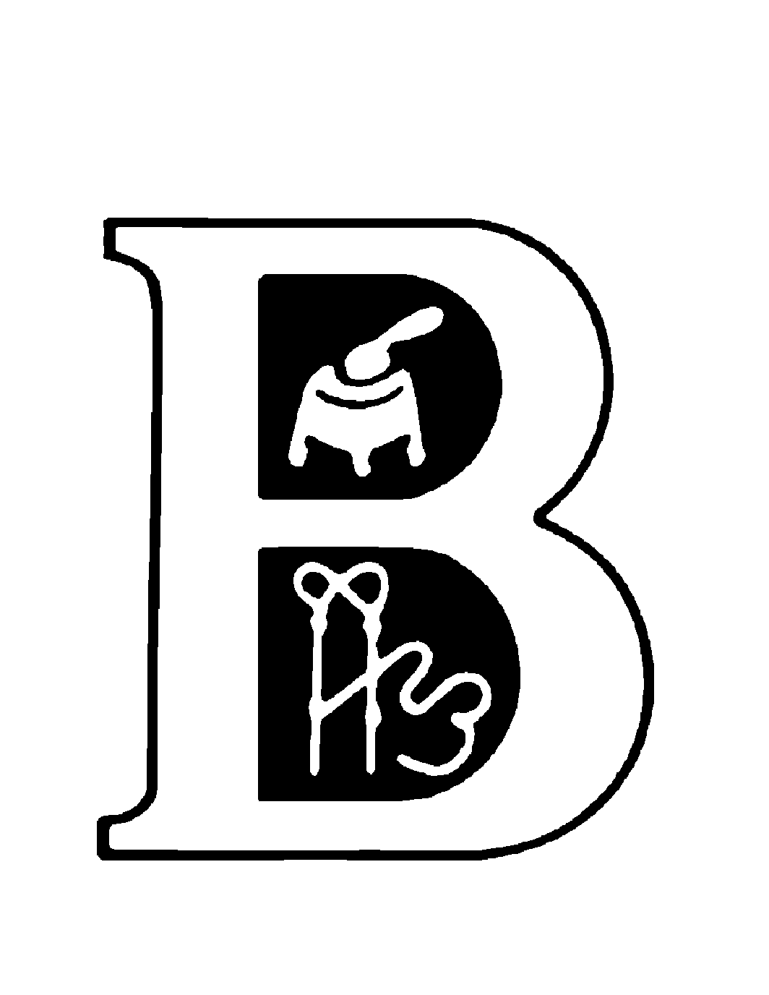
Overall Champion: $500
Res. Overall Champ: $400
3rd Overall: $300
4th Overall: $200
5th Overall: $100
Judges

Heifers: TBA

Steers: Jeff Sargent

Entries available at:

http://www.canr.msu.edu/blockandbridle/

Show Chairpersons:
Andrea Williams Rachel Gleason Brandon Goering Brady Littlefield
(989) 701-6020 (269) 591-4453 (419) 551-5461 (269) 503-0407
will3107@msu.edu gleaso91@msu.edu goeringb@msu.edu littl103@msu.edu

2018 Rules & Requirements
Please read carefully before calling with questions.
1. ELIGIBILITY: Open to youth that are between the ages of 8 and 21 as of January 1st, 2018. All cattle must be solely owned by the exhibitor making the entry.

2. ENTRIES: Entry fees are a non-refundable $50 for each entered animal. Entries must be postmarked on or before Friday, March 9, 2018. Late entries are $100 per head and will be accepted until Saturday, April 7th at 9 p.m. An exhibitor may enter up to 4 breeding heifers and 2 market animals. THE EXHIBITORS MUST SHOW THEIR OWN ANIMAL. ID MAY BE REQUIRED AT THE DISCRETION OF THE SHOW COMMITTEE.
A complete entry consists of date of birth, breed of animal, and showmanship preference. Entries not providing all this information will NOT be accepted and will be required to late enter at check-in and pay the $100 late entry fee. Entry fees may not be transferred to another exhibitor. All cattle late entered will be required to pay the $100 late fee, with the exception of heifers purchased in the Expo sale on 4/7/2018.
Please send entries and entry fees to: MSU Block & Bridle Make checks payable to:
474 S. Shaw Lane Michigan State University Block & Bridle Club
1290 Anthony Hall
East Lansing, MI 48824
PLEASE Note: Stalling assignments in the main pavilion will be based on date of entry. Stalls will be assigned in the south barn.

3. ARRIVAL: Cattle must be in by 9 p.m. on Saturday, April 7th. NO CATTLE OR TACK ARE TO BE UNLOADED IN THE MAIN BARN BEFORE 5 P.M. ON SATURDAY! Please be considerate of sale cattle being loaded out on Saturday afternoon near the main Pavilion. If cattle and/or equipment are in the main barn before the posted time you will be disqualified and asked to leave immediately. Entry Directions: Cattle arriving from the Modified Accredited Zone must go to the show office and show their movement permit before unloading. Early arrival option: Cattle may arrive on Saturday from 8 a.m. to 5 p.m.; however, they will be permanently stalled in the South Barn. Outdoor tie-outs will be available.

4. PARKING: NO CATTLE ARE TO BE STALLED NEXT TO ANY TRAILER. Trailers MUST be parked on paved surfaces with the ONLY exception being near the South Barn. Vehicles and trailers can be parked in the lot across farm lane but NO cattle are to be stalled in/near trailers in this lot. Trucks and trailers will not be allowed to park in the area immediately west of the main arena.

5. STALLING REQUESTS: To specifically stall with another exhibitor, your entries must be received in the same envelope, stalling assignments are based on the date of receipt of the entries. Main barn will be assigned first and the south barn will NOT have assigned stalling, it will be a first come first basis. Exhibitors do not have to clean their stalls. Note: Entry of sale cattle does not guarantee the stall assignment of the purchased animal(s).

6. CHECK-IN: Early check-in will be at the South Barn from 1- 4 p.m. on Saturday, April 7th. Cattle CANNOT be in the Main Pavilion until 5 P.M. Check-in will continue from 6 p.m. to 9 p.m. in the east end of the Pavilion. Pick up exhibitor packets before taking cattle to check-in. Registration certificates must be presented at check-in time. Tattoos and RFID tags (required) will be checked and must correspond to registration papers. Registration applications, faxes or photocopies will not be accepted. Animals can only enter the “check-in chute” one time.

7. ANY OTHER REGISTERED BREEDS & COMMERCIAL/ MARKET DIVISION: The AORB division will include all breeds not listed in the “show times and order” section. Market animals that are not registered will be shown in the crossbred steer, market heifer or commercial heifer division. Crossbred steers, commercial and market heifers will be shown by weight.

8. BREED REQUIREMENTS: For the following breeds, the animal must meet the percentage requirement listed below.
Charolais Composite- Must present papers
Purebred Simmental Heifers– 7/8 or greater
Simmental Solution Heifers – 25%- 49%
Percent Simmental Heifers – ½ - 7/8
Simmental Steers – 50% or greater
Percent Simmental Steers – ½ - 7/8
Maine-Anjou – 75% and above
Maintainers – 25% to 74%
Shorthorn Plus- 50% Steers & Heifers
(Lower Percentage Steers will be in AORB)
MSU Block and Bridle Beef Expo Committee reserves the right to adjust breed classes accordingly, based on our discretion.

9. PURCHASE OF SALE CATTLE: Heifers purchased in a breed sale on Saturday may show at the junior show on Sunday with no charge for late entry but will still be charged the original entry fee of $50. You will need to provide:
a) a sale entry form signed by the sale clerk or manager b) a bill of sale showing that the animal will be registered in the junior exhibitor’s name c) a copy of the registration paper and d) a copy of the animal’s health paper (if purchased from an out of state consignor).

10. MICHIGAN OWNED: All cattle exhibited by Michigan residents are eligible for the Michigan Owned awards.

11. AWARDS: Champion breed heifers and steers will receive $60, and Reserve breed champions will receive $30. Top 5 Overall Market Animals and Breeding Heifers will receive $500 for Grand, $400 for Reserve, $300 for 3rd, $200 for 4th and $100 for 5th. Champion and Reserve Michigan Owned will be selected and awarded a banner. All Class premiums are based on a sliding scale and will be given to the exhibitor as they exit the ring. NO REFUNDS OR LOST PREMIUMS WILL BE REIMBURSED.

12. SHOWMANSHIP: Exhibitors pre-register for showmanship on entry form and pay $5. After March 9th, showmanship will be $10 per exhibitor. Thus, participants can sign-up for showmanship during check-in times for $10. Showmanship will begin at 8 a.m. Sunday morning with seniors (16-21) followed by intermediates (13 to 15), then juniors (10 to 12) and beginners (8-9). Classes will be divided by age as of January 1st, 2018. Exhibitors must show their own animal.

13. GROOMING REGULATIONS: ABSOLUTELY NO aerosol cans are allowed in the make-up area.
Use of false tail heads or adding of hair or hemp is prohibited. NO forced administration of fluids to create gut fill will be allowed. Violation will result in the disqualification of the entry and exhibitor.

13. RESPONSIBILITY: The MSU Block and Bridle Club will not be responsible for any loss by death, injury, crippling, bruises, theft or condemnation.

14. PAVILION RULES:
- Alcoholic beverages prohibited. In accordance with University policy.
- NO fans are allowed behind the cattle or in the aisles unless suspended overhead.
- A maximum of one fan per three head of cattle is allowed.
- No generators will be allowed in or around the Pavilion, they must be located a minimum of 20ft from any building.
- Dogs are not permitted in the Pavilion at any time during this event.

15. DANGEROUS ANIMALS: Animals must be under control of the exhibitor at all times. For safety, the show committee will request that dangerous animals be removed.

Breeding Heifers
1. SHOW TIMES AND ORDER: Heifers will show in the South ring beginning 10 minutes after the last showmanship class. The show order will be: Charolais Composite, Commercial, Purebred Simmental, Percent Simmental, Simmental Solution, Shorthorn, Shorthorn Plus, Maine-Anjou, Mainetainer, Hereford, Chi, Angus, Charolais, AORB (Any Other Registered Breeds), Top 5 Overall Heifers.

2. Heifers born from September 1, 2016 thru September 31, 2017 are eligible to show.

3. Registered heifers within breed will show from youngest to oldest. All heifers entered in a specific breed must be registered solely in the name of the youth exhibitor with their respective national breed association. Registration certificates must be presented at check-in time. All breeding heifers must be tattooed and tattoos must correspond to registration papers. Heifers that are dual registered can show with only one breed and must be entered as such.

4. Commercial and market heifers will be shown by weight and all registered heifers will be shown by date of birth. Commercial heifers will compete for Supreme Heifer, and market heifers will compete for Overall Champion Market Animal.

Prospect Steers and Market Heifers

1. SHOW TIMES AND ORDER: Steers will show in the North ring beginning 10 minutes after the last showmanship class, in the following order: Angus, Chi, Hereford, Maine-Anjou, Mainetainer, Shorthorn, Shorthorn Plus, Simmental, Percent Simmental, Charolais Composite, Crossbred, AORB (Any Other Registered Breeds), Market Heifers, and Top 5 Overall Market Animals.

2. Prospect steers will be shown by breed and weight. All steers entered in a specific breed must be registered solely in the name of the youth exhibitor with their respective national breed association. All steers entered in a breed will abide by the rules for registry and showing. Registration certificates or performance pedigrees must be presented at check-in time. All breed steers must be tattooed and tattoos must correspond to registration papers. Steers that are dual registered
can show with only one breed and must be entered as such.

3. Market heifers will be shown by weight. There will be no breed classes for market heifers and they may not be shown in breeding classes.

Become a Sponsor of the
Michigan Beef Expo Junior Show

Now is the time to become a sponsor for the 2018 Michigan Beef Expo Junior Show. All donors will be recognized as the award is presented to the junior exhibitor. This is a great way to show your support while publicizing your business.

Please check one or more of the following options. Donations will be filled on a first come first serve basis. If your desired placing is already taken you will be contacted.

Top Overall Heifers Top Overall Steers
_______ $500 1st Place Overall Heifer _______ $500 1st Place overall Steers

_______ $400 2nd Place Overall Heifer _______ $400 2nd Place Overall Steers

_______ $300 3rd Place Overall Heifer _______ $300 3rd Place Overall Steer

_______ $200 4th Place Overall Heifer _______ $200 4th Place Overall Heifer

_______ $100 5th Place Overall Heifer _______ $100 5th Place Overall Heifer

Breed Champions
_______$75.00 Grand Champion Heifer, Specify Breed: ____________________________________________

_______$50.00 Reserve Champion Heifer, Specify Breed: __________________________________________

_______$75.00 Grand Champion Steer, Specify Breed: _____________________________________________

_______$50.00 Reserve Champion Steer, Specify Breed: ___________________________________________

Other
______ $150 Back Tags (exhibitor numbers) *Provided by Sponsor*
______ $225 Back Tags (exhibitor numbers) *NOT Provided by Sponsor*
______ $350 Backdrop Sponsor
______ $175 Ring Sponsor *Banner MUST be provided by Sponsor

$________Total Amount Donated

Checks can be mailed payable to: MSU Block & Bridle Club
Please mail sponsorship form/check separately to:

MSU Block & Bridle Beef Expo
474 S. Shaw Lane, Rm 1290
East Lansing, MI 48824

Thank you for supporting the Michigan Beef Expo. The juniors and MSU Block & Bridle Club appreciate your support!

B&B Junior Show Entry Form Sunday April 8, 2018
MSU Pavilion, East Lansing, MI

Entries Due: Friday, March 9, 2018 Fee: $50/head --- Late Fee: $100/head

See # 11 for information on show and entries

Please print legibly and include all exhibitor information. Use one entry form for each youth entering.
No telephone or fax entries. Entries must be postmarked by Friday, March 9, 2018.
Exhibitors’ Name: |  | Phone: (xxx)-xxx-xxxx
Address: |  | County:
City: | State: | Zip: | Date of Birth: (mm/dd/yyyy)

Market Prospects (max 2) $50/head
Reg. Name |  |  |  |  | Tattoo |  |  |  |  | Date of Birth |  | Breed | MH or S
Breeding Heifers (max 4) $50/head
Reg. Name |  |  |  |  | Tattoo |  |  |  | Date of Birth |  |  | Breed
Camping ($20/space/night) |  | Number of Nights: |  |  |  |  |  | Number of Camping Sites:  Please make checks or M.O.’s payable to: MSU Block & Bridle. One check per family with all exhibitors listed may be sent. Mail to: MSU Block & Bridle 474 S. Shaw Ln, 1290 Anthony Hall, East Lansing, MI 48824
Showmanship  $5 per exhibitor |  |  | Yes | No
Total Entry & Camping | $

Exhibitors are responsible for reading and adhering to the rules. Please sign FULL FIRST AND LAST NAME below to indicate the rules have been read and understood.

_____________
Exhibitor Signature

Stalling request: Stalling requests MUST be made by mailing all exhibitor entries together, NO EXCEPTIONS.

Do you have sale cattle stalls for Expo that you wish to retain: yes no
If yes, breed, farm name and last name the stalls will be under:

________________________________________________________________________________

REQUESTS TO BE STALLED IN SALE CATTLE STALLS MUST BE MADE ON THIS FORM OR THEY WILL NOT BE CONSIDERED, NO EXCEPTIONS. Entry of sale cattle does NOT guarantee stall assignments in sale stalls. Note: Stalling will be assigned on first come first serve basis, assignments will be made in the south barn after the main pavilion is filled.

TB and Health Requirements

TB Test Requirements

All Michigan cattle participating in the 2017 Michigan Jr. Beef Expo Show must have an RFID tag. Neither an official USDA alphanumeric metal ear tag nor an official breed registry tattoo will be accepted in place of an RFID tag.

For questions regarding TB Zone cattle requirements please refer to Michigan Department of Agriculture and Rural Development http://www.michigan.gov/documents/mdard/2015_Fairs_and_Exhibition_Requirements_478159_7.pf

OUT OF STATE/ COUNTRY CATTLE –
- Out–of-state cattle must be accompanied by a certificate of veterinary inspection (health certificate) that lists the animal’s official identification EXACTLY as it appears on the animal.
- Official identification is either a USDA alphanumeric metal ear tag OR an official electronic identification tag (RFID tag) OR an official breed registry tattoo that is unique to that individual and corresponds exactly to the tattoo identification number on official breed registration papers. RFID tags can be purchased on site.
- Fair tags, bangle tags, tattoos that do not match registration papers, and tattoos in non -registered cattle are NOT official identification.
- For questions regarding requirements to move cattle into Michigan call the Michigan Department of Agriculture 517-373-1077.

Additional Health Requirements
- All cattle must be dehorned, horn length cannot be greater than two inches.
- Cattle infected with a communicable disease may not be brought to the show. To meet the health standards required to show, animals need to be free of illness including but not limited to:
  - Clinical signs of respiratory disease (watery eyes, nasal discharge, elevated temperature, excessive slobbering)
  - Active ringworm and/or warts
  - Identifiable external parasites
- Evidence of surgical, conformation or any other unethical alterations will result in the animal and exhibitor being disqualified from competition.
- Animals not meeting these standards are to be removed from the Pavilion immediately upon notification to the exhibitor and/or parents to retain his/her ability to exhibit in future B&B shows.
- Health Certificates are required for out-of-state cattle and must comply with the State of Michigan health requirements.

