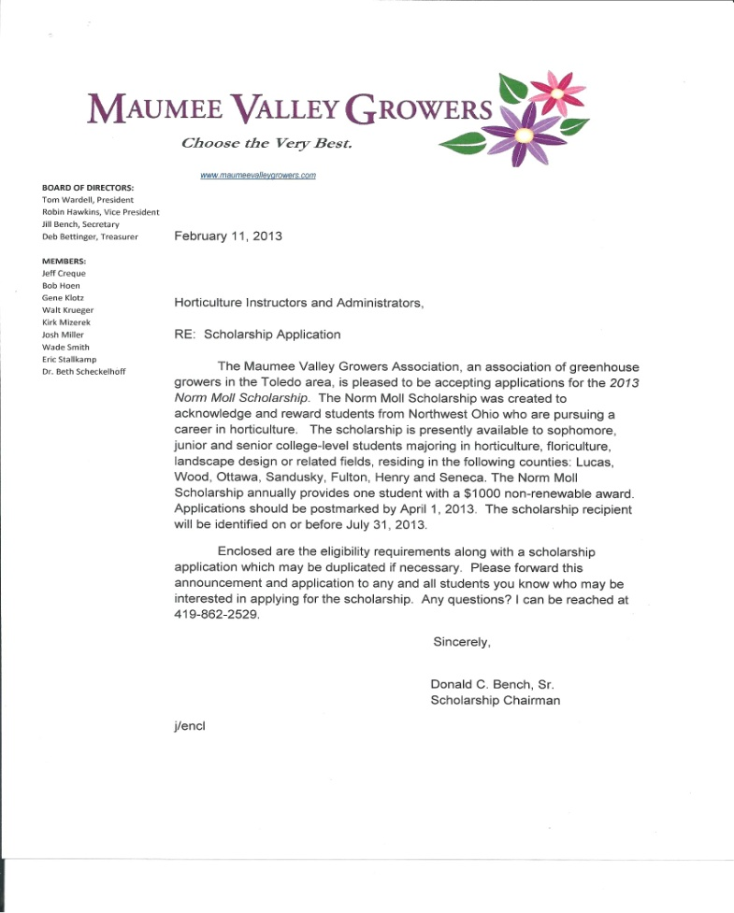

Joe Perlaky, Executive Director March 1, 2017
Jill Bench, President
Deb Bettinger, Vice President
Josh Miller, Secretary
The Maumee Valley Growers Association is pleased to be accepting applications for the 2017 Norm Moll Scholarship. The scholarship was created to acknowledge and reward students from Northwest Ohio/Southeast Michigan who are pursuing a career in horticulture. The scholarship is presently available to current freshmen, sophomore and junior students attending college or high school senior majoring in horticulture, floriculture, landscape design or a related field. The scholarship annually provides students with an up to $1000 non-renewable award. Applications should be postmarked by June 15, 2017. The scholarship recipient will be notified by July 31, 2017.
Enclosed is the eligibility requirement, along with a scholarship application which may be reproduced, for any eligible high school senior or graduate now attending college whom you deem fit to apply. Please forward this announcement and form to those who you think may be interested in applying for the scholarship in 2017.
Sincerely,
MAUMEE VALLEY GROWERS
Jill Bench
Jill Bench, President

Bob Hoen, Treasurer
Wade Smith, Member
Kim Bunge, Member
Jeff Creque, Member
Ralph Keefe, Member
Walt Krueger, Member
Ian Hoen, Member
Eric Stallkamp, Member
Anne Schenk, Member
Jennifer Boldt, Member

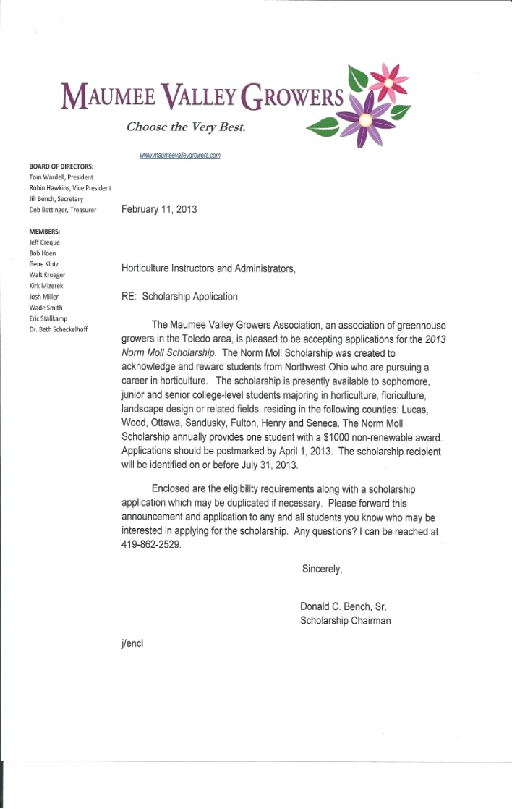

The Maumee Valley Growers Association
A membership of Independent Greenhouse Growers in Northwest Ohio, is offering the

NORM MOLL SCHOLARSHIP

An applicant shall be a high school senior, freshman or sophomore attending college, who are from Northwest Ohio or Southeast Michigan and must or will be enrolled in Horticulture, Floriculture, Landscape Design or similar program at an accredited college or university.
Applicant must have a cumulative 2.5 GPA.
The following schools in Ohio offering these courses are (but not limited to):

Cincinnati State Technical & Community College
Clark State Community College
Kent State University
The Ohio State University
Ohio State University Agricultural Technical Institute
Owens Community College
University of Cincinnati
Wilmington College

In an effort to encourage students to pursue a rewarding career in these fields, we have established this one-time $1,000.00 scholarship in memory of Mr. Moll, a longtime County Extension Agent here in Northwest Ohio. This scholarship annually recognizes one student for their excellence and commitment in pursuing a career in our field.

APPLICATION DEADLINE: June 15, 2017. Applicants will be notified of the award selection by July 31, 2017.

Please mail completed applications to:

Mrs. Jill Bench
MVGA President
18063 W State Route 105
Elmore, OH 43416
419-862-3596
jillbench@yahoo.com

The Maumee Valley Growers Association

NORM MOLL SCHLORSHIP APPLICATION

Please complete the following application, attach a copy of your most recent college transcript and submit both by June 15, 2017.

NAME OF APPLICANT:___________________________________________________

Address:_______________________________________________________________________________________
City:_________________ County:_____________________ Zip Code:_____________

Telephone: _________________________ Email:_____________________________

Applicant must be from one of the following counties:

___ Fulton ___ Henry ___ Lucas ___Ottawa ___ Sandusky ___ Seneca ___Wood

I am presently enrolled as a: ____ Freshman ____ Sophomore ____ Junior at

____ Cincinnati State Technical Community College
____ Clark State Community College
____ Kent State University
____ The Ohio State University
____ Ohio State ATI
____ Owens Community College
____ University of Cincinnati
____ Wilmington College
_____Other

Major Field of Study:_____________________________________

Please describe any activities, efforts and/or awards you have received thus far in your educational pursuit:

Please continue on reverse side if necessary.

Please describe how you became interested in pursuing a career in horticulture (you may attach additional sheets if necessary.)

Please describe your career plans and objectives in the field of horticulture (you may attach additional sheets if necessary.)

Signature: ____________________________________

Signature (please print): _________________________

Date: _______________________________________

