Dear Ingham County 4-H Member:

The Ingham County 4-H Council invites you to apply to become a Citizen Washington Focus Delegate for the summer 2020 Citizenship Washington Focus (CWF) program, 4‑H’s premier leadership and citizenship program for high school students. CWF is more than a Washington, D.C. field trip – it’s an opportunity for 4‑H’ers to learn how to be citizen leaders and make a difference in their communities. If you are interested, complete the following requirements to be eligible for this program:

- Submit the application below to Glenda Weiss (weissgle@msu.edu) by October 11, 2019. Your application must also include two letters of recommendation. At least one from a 4-H volunteer or extension staff member and another one from a community member, however both can be from 4-H volunteers. Parents and family members are not allowed to sign the recommendation letters.
- Interviews will be held the week of October 14th-17th and will be arranged by Glenda Weiss.
- After the completion of the trip, youth are required to provide a presentation regarding what they learned to the Ingham County 4-H Council, at the following Ingham County Awards Banquet, and to all entities that provide scholarships for the trip. Thank you letters are also required for all entities that provide scholarships to the trip.
- The cost is the trip is approximately $1,450 and the youth are responsible to this fee, however we encourage youth to fund raise for the event.
- Youth ages 14-19 can attend. See the website for more information: https://4-h.org/parents/citizenship-washington-focus/

Good luck!
The Ingham County 4-H Council

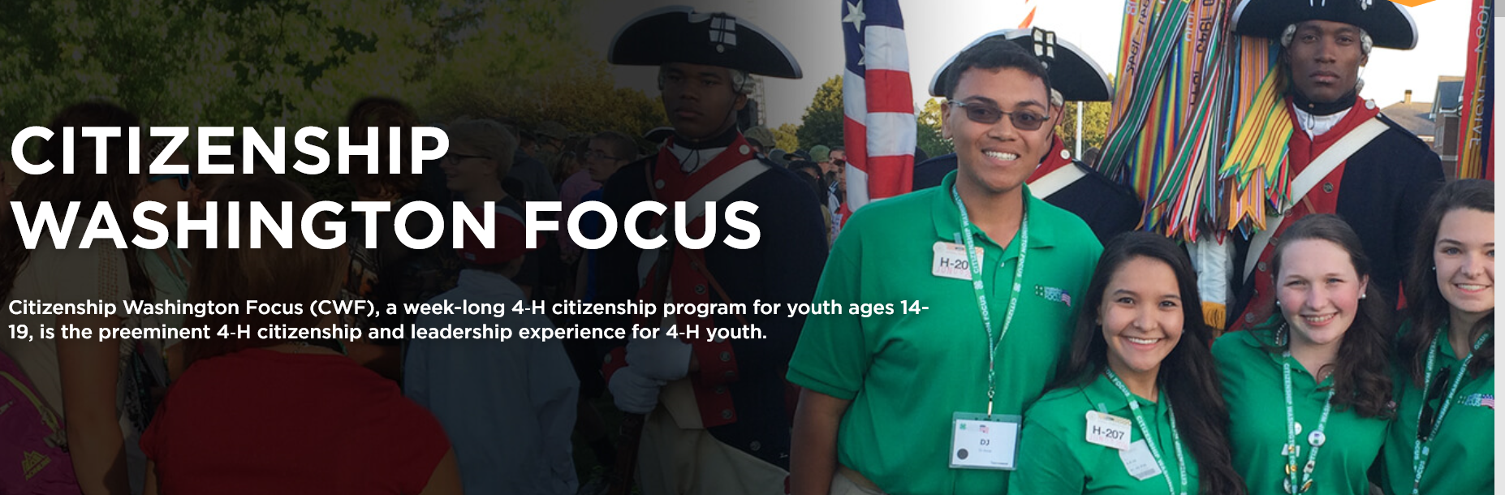

Please print in ink or type.

Ingham County 4-H
Citizenship Washington Focus 2020 Delegate Application

Last Name
First Name
Middle Initial

Male
Female
Birthdate - -
Address

City Zip

County Grade in School, as of Jan 2020

Your Home Phone ( ) Your Cell Phone ( )

Your Email address

Parent/Guardian’s Name

Parent address (if different than yours)

Parent Home Phone ( ) Parent Cell Phone ( ) Parent Email

Your U.S. Congressional Representative

Why do you want to attend Citizenship Washington Focus? Response must be a minimum of 250 words and a maximum of 500 words.

What do you hope to gain from this experience and how do you plan to share information when you return? Response must be a minimum of 250 words and a maximum of 500 words.

List what you consider your two (2) most valuable leadership experiences as a 4-H member: Response must be a minimum of 250 words and a maximum of 500 words.

Have you participated in any civics/government classes, activities or organizations? if so, briefly list here:

As parent/guardian of , I understand that he/she is applying to attend the 2020 Citizenship Washington Focus (CWF) trip to Washington, D.C. I have read the information and policies stated in the 2020 flyer and understand that, if the applicant is chosen to be a delegate, all payments must be made on time. I also understand and accept the cancellation policy provided. I also understand that it is highly recommended that the applicant join the 4-H Teen Ambassadors in 2019-20. Many leadership and scholarship opportunities for CWF are available to Ambassadors.

Parent/Guardian Signature

Date

4-H Youth Signature

Date

Return this application to Ingham County Extension Office by October 11, 2019. Delegates will be announced at the County Awards Banquet in November

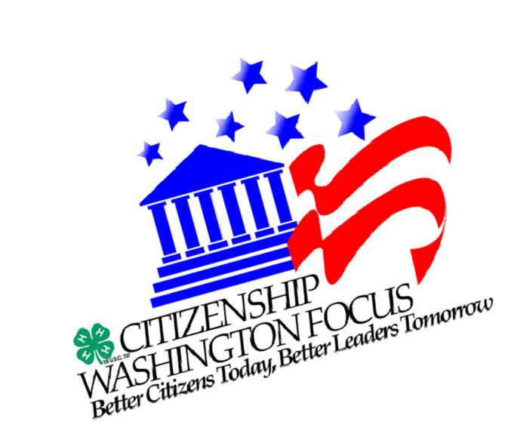
4-H Citizenship Washington Focus

Late June, 2020 (Dates TBD)
Washington, D.C.

Citizenship Washington Focus (CWF) is a 4-H leadership program for high school youth ages 14-19 from across America. Thousands of young people come to the National 4-H Youth Conference Center, near Washington, D.C., every summer to participate in a week-long program that enriches the lives of young people through activities that broaden their appreciation and respect for themselves and others.

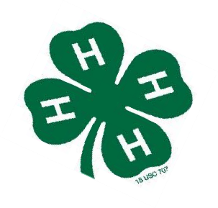
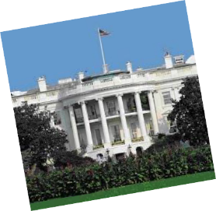
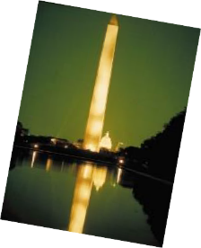
Learn Leadership, Live History,
Explore Your Nation!
Saturday, June TBD
Board chartered bus to travel to D.C.
Hotel stay en route in Gettysburg , PA
Sunday thru Friday, June TBD, Citizenship Washington Focus
- Lodging at the National 4-H Youth Conference Center, Chevy Chase, MD
•
•
•
•
Tour National Monuments, the United States Capitol, Smithsonian, Arlington National Cemetery, Dinner Theatre, National Archives and Mt. Vernon
Meet with elected officials Leadership Training
& Fun!
Saturday, June TBD
Arrive Home
Cost: Approx. $1,450

Installments due January 15 ($500), February 1 ($500), March 15 ($450), 2020
Price includes lodging, most meals, transportation, & all entry prices to tour sites. Only expenses not included are cost of souvenirs & six meals.

Cancellations received after February 1, 2020 will not be refunded.

It is highly recommended that all youth applicants join the Ingham County 4-H Teen Ambassadors Program in 2019-20. If accepted as a CWF delegate, many scholarship opportunities are available to Ambassadors. For information on how to become an Ambassador, please contact the 4-H Council through the MSU Extension office.

