Downloading Health Forms
Before You Start
Health forms can be downloaded from the Member, Participation, and Registration search screens, as well as the Units/Clubs page for the selected Unit/Club.
Health form downloads are password-protected, due to the sensitive nature of the information.
Steps  - From the Member, Participation or Registration Search, complete the search for your intended members.  - Click the Health Forms button. A selection menu will appear.  - Select your preferred file format for the exported information.  - Excel/PDF – all forms in one document  - Zip – each form is its own file and be named as CountyName_LastName_FirstName  - Audit (available only on Member Search) – can include previous years’ health forms.  - Click the clipboard icon in the Password Protected File window. This will copy the Manager password to open the protected file.  - Click the Download button. | Screenshots  (Screen appearance may vary per state)  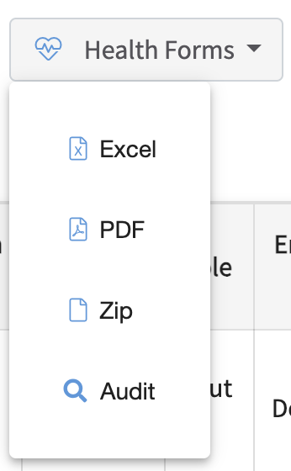  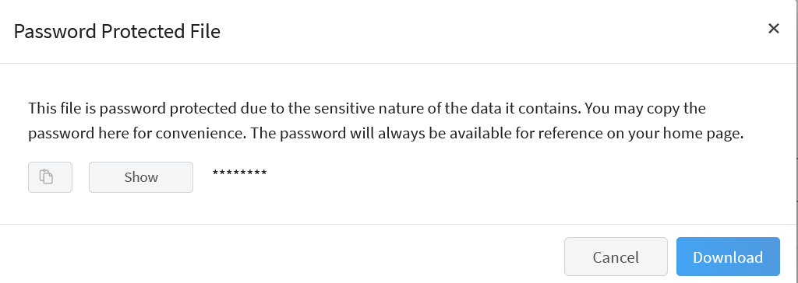
- When opening the file, you will be prompted to enter the Manager Download Password.  - Paste the password into the prompt and click OK.  - Health Forms can be printed as needed. | 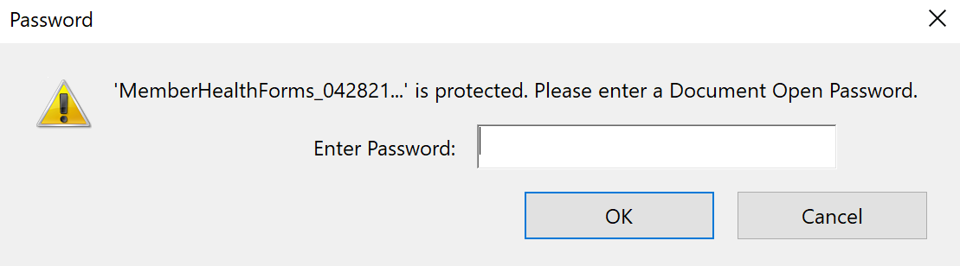
Tips
The download password can also be retrieved at any time from the Manager’s Home Screen, if the file is opened at a later date.

