Allowing Members to Edit Projects and Clubs After Approval
Before You Start
The System Manager manages the request to turn on this feature for the state.
The Primary Hierarchy Admin for each County sets the County restrictions for families editing clubs and projects on approved enrollments.
There are separate settings for allowing Units/Clubs and Projects to be edited by the family after the enrollment has been approved.
Steps  - Only the Primary Hierarchy Admin for the county can change these settings.  - Click on Settings in the navigation pane.  - Scroll to the section titled “Member”.  - Click the Edit button. | Screenshots  (Screen appearance may vary per state)  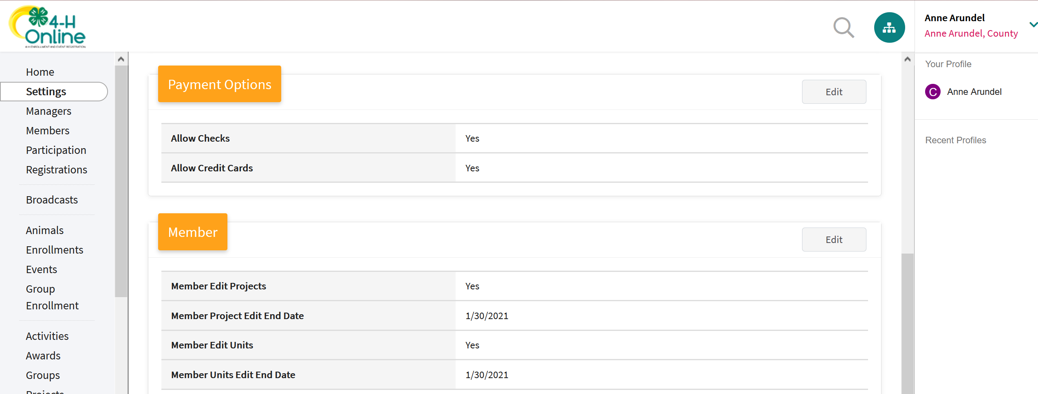
- (Projects) Check the Box to turn on Member Edit Projects.  - Set the member Edit Project End Day if different than the state deadline.  - Set the Member Edit Projects End Month if different than the state deadline.  - (Clubs/Units) Check the Box to turn on Member Edit Unit (Club).  - Set the Member Edit Unit End Day if different than the state deadline.  - Set the Member Edit Unit End Month if different than the state deadline.  - Click Save. | 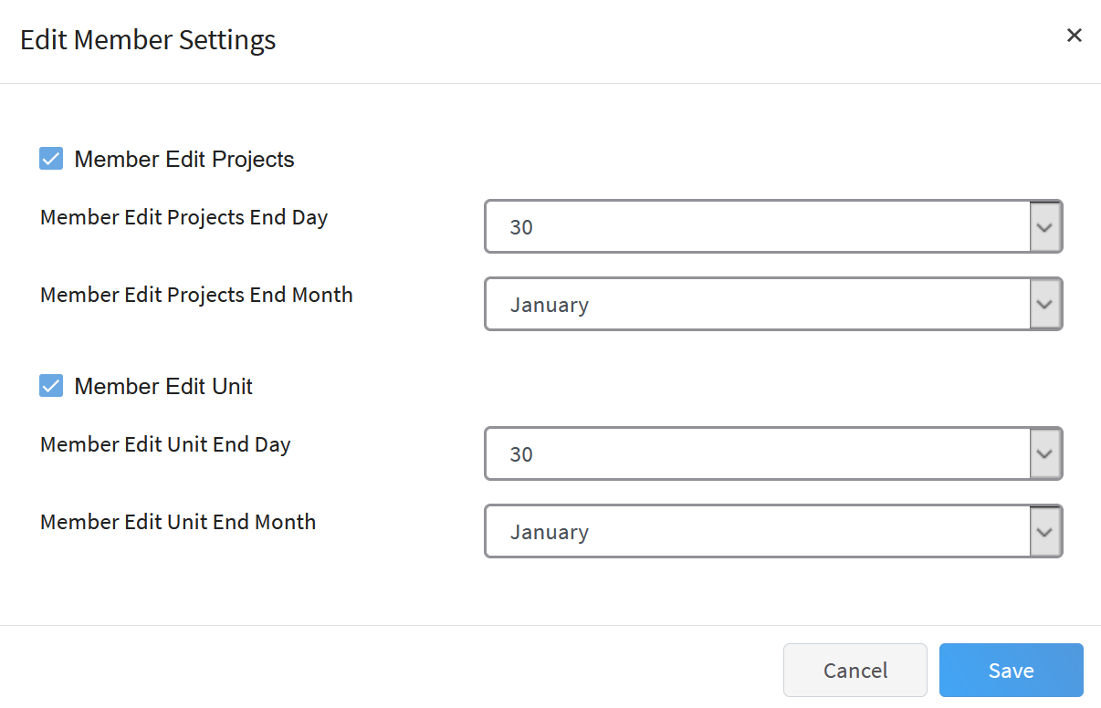
Tips
- The County Settings remain turned off (members are not able to add clubs or projects to approved enrollments) until the Primary Hierarchy Admin enables the settings.
- If the County turns on the options to allow Members to edit projects or clubs but does not set a date, the families will be restricted to the state deadline.
- If a date is entered, the County-provided end day and month overrides the date set by the state.
- The end dates must be within the current program year.

