Creating Groups
Before You Start
- Institution Managers may create State level groups.
- County Managers may create County level groups.
- Click on Groups in the navigation pane.  - Click the + Add Group button. | 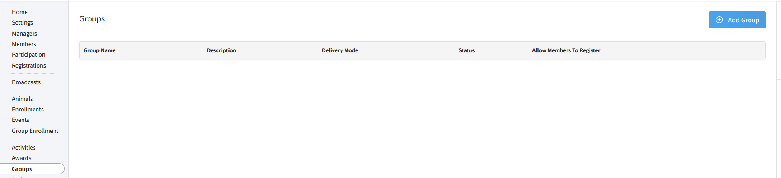
- Enter the Group Name.  - Enter a Description of the Group.  - Select the appropriate Delivery Mode of the Group. (NOTE: This will NOT create a Group Enrollment from the Group)  - Select the status of the Group. (Active, Inactive)  - If Members are allowed to register themselves for the Group, check the box.  - Click Add to create the group. | 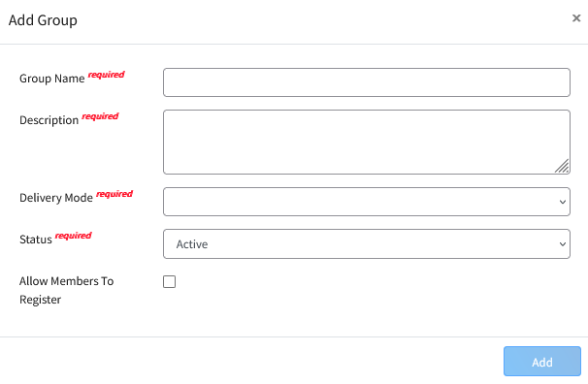

Modifying a Group
Before You Start
It may become necessary to clean up the list of groups that are available to be added to Member records. By setting the group to Inactive, the group will remain with the member’s history, but will not be available to add to member records moving forward.
- Click on Groups in the navigation pane.  - Select the Group that you would like to modify.  - Click the Edit button for the Group Details. | 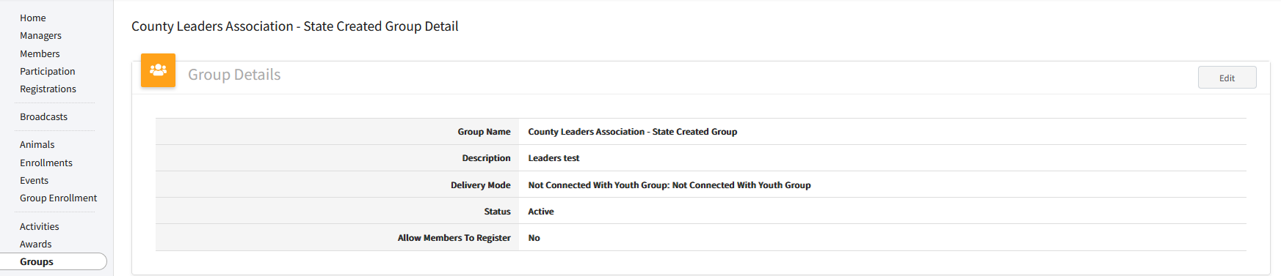
- You may change the status to Inactive if the group is no longer being used.  - You may update the Label, Description, Delivery Mode, and whether Members may register themselves for the group without changing the status of the Group.  - Click the Save button. | 