Participation Search
Before You Start
The Participation section allows Institution and County Managers to search for members based on the way they are participating in the program. This includes units, roles, status, projects, groups, activities, and awards.

Steps  - Click on the Participation tab in the navigation pane.  - Enter keywords, or use the filter options for the search.  - The fields with the diagonal grey arrow box allow for multiple selections.  - The Flagged option limits results to records that were flagged on the Member Search screen.  - (Inst. Mgr.) Before selecting a Unit, you must first select the County, then the Units area will populate for selection.  - Click the Search button to find matching records.  - Click the Clear Filters link to reset the filters. | Screenshots  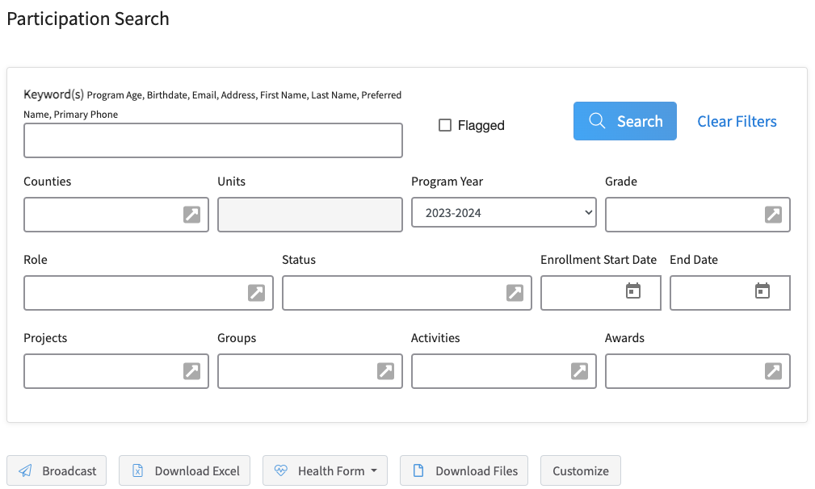  (Screen appearance may vary per state)
- The results will be displayed below the search area.  - The results will display 50 records at a time. Click the > button to view additional pages of results if applicable.  - Use the Customize button to select from a list of fields to appear on your search screen. | 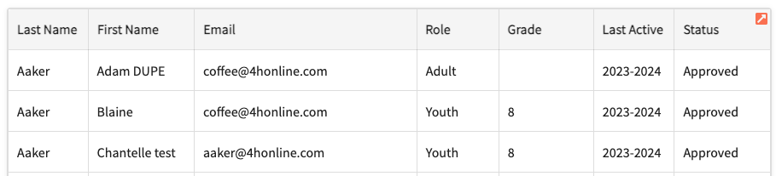
- At the top of the list of results, there are options for Broadcast (send an email to members listed on screen), Download Excel (download the information on screen as an Excel file), Health Forms (Excel, PDF, Zip, or Audit file), and Download Files (enrollment custom files).

- Click on a Member to view the detailed member information, including Years in Program, Screenings, Trainings, Events, Units, and Projects. | 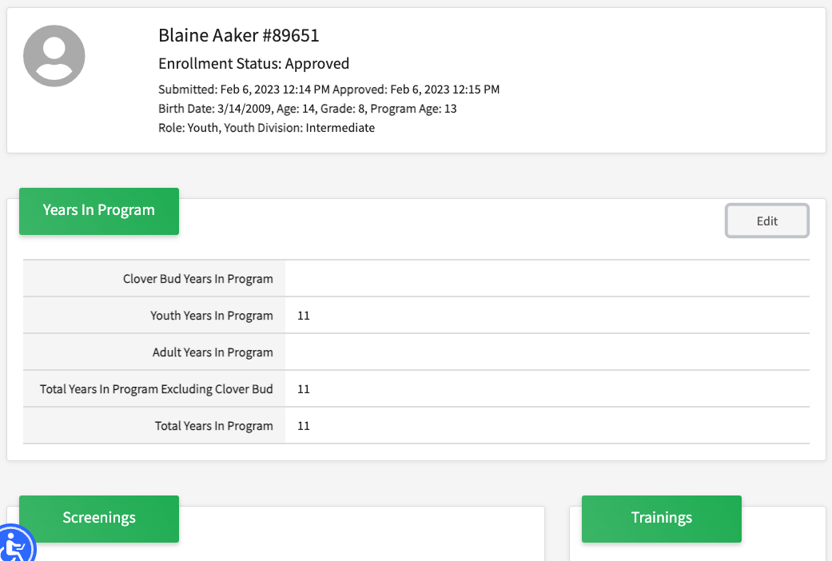
- Click on the Profile link in the Navigation pane to view Profile Notes, Profile, and Family Information.  Note: at the bottom of this screen are options to Dismiss, Archive, Mark Deceased and Delete the record. The options to dismiss or delete member profiles are restricted to Institution Managers. | 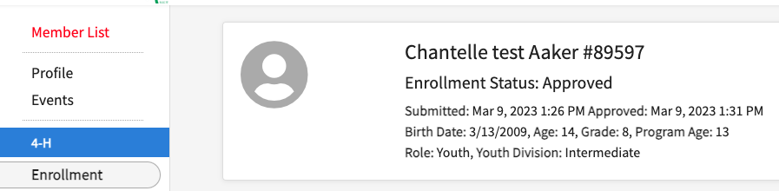
- Click on the Events link in the Navigation pane to view information about events for the member. | 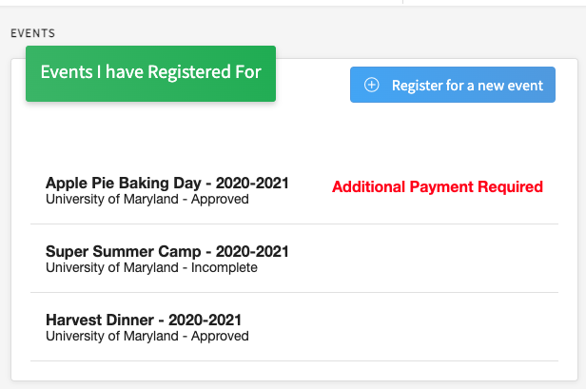
Tips
The search filter for Counties is limited to Institution Managers. The program will restrict County Manager search results to members and families in the manager county.

