Michigan State University Extension

Health and Nutrition Institute
Nutrition and Physical Activity Workgroup
Project Fresh Evaluation
Prepared by: Olga J. Santiago Rivera, MHSA, Ph.D. & Bette Avila, MPA
October 18, 2012

MSU is an affirmative-action, equal opportunity employer. Michigan State University Extension programs and materials are open to all without regard to race, color, national origin, gender, gender identity, religion, age, height, weight, disability, political beliefs, sexual orientation, marital status, family status, or veteran status.

In accordance with Federal law and U.S. Department of Agriculture policy, this institution is prohibited from discriminating on the basis of race, color, national origin, sex, age, religion, political beliefs or disability. To file a complaint of discrimination, write USDA, Director, Office of Civil Rights, 1400 Independence Avenue, S.W., Washington, D.C. 202509410 or call (800)795‐3272 (voice) or (202)720‐6382 (TTY). USDA is an equal opportunity provider and employer. The Supplemental Nutrition Assistance Program (SNAP) provides nutrition assistance to people with low income. It can help you buy nutritious foods for a better diet. To find out more, call your local MSUE Extension office at 1-888-MSUE-4MI (1-888-678-3464) or check online at http://msue.msu.edu. For SNAP benefits, call your local DHS office at 1-855-ASK-MICH (1-855-275-6424), or check online at http://michigan.gov/dhs/.

MI Project FRESH – Nutrition Education at Farmer Markets
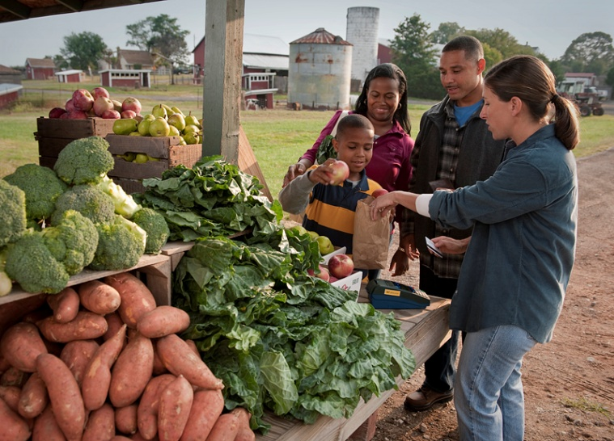
Description
MSU Extension offices statewide deliver Project FRESH services to certified participants. MSUE delivers Senior Project FRESH and WIC Project FRESH.
The Senior Farmers Market Nutrition Program, known as Senior Project FRESH/Market FRESH in Michigan, provides older adults who qualify with unprocessed, Michigan-grown products from authorized farmers markets and roadside stands throughout Michigan. Senior Project FRESH/Market FRESH originates from US Dept. of Agriculture (USDA) funding. It is part of the Senior Farmers Market Nutrition Program. These federal dollars come out of the federal Farm Bill. The program was designed to benefit both farmers and seniors. To qualify, and older adult must be: 60 years of age or older; have a total household income of 185% of poverty or less; live in the county where the coupons are issued (Source: http://www.michigan.gov/miseniors).
WIC Project FRESH is an educational program providing participants with coupons to purchase locally grown fresh fruits and vegetables at participating farmers’ markets. It plays an important role in helping families eat more fruits and vegetables. It also benefits local farmers by providing them with additional income through the redemption of the Project FRESH coupons.

During the 2012 summer MSUE reached nearly 18,000 participants of Project FRESH. WIC Project Fresh outreached 68 counties.

2012 WIC Project Fresh Evaluation
This section presents an evaluation of 2012 WIC Project Fresh. It includes only those counties that administered the evaluation form, and that had reported the results prior to the preparation of this report.

1. Project Goal and Background
Goal: To create awareness of the nutritional benefits of fruits and vegetables, thereby increasing consumption.
Core nutrition message:
- Eat the recommended servings of fruits and vegetables daily (2 ½ to 3 cups).
Participants will be able to:
- Discuss the benefits of eating various fruits and vegetables.
- Identify ways to incorporate more fruits and vegetables into their diets.
Background:
Many Americans do not consume the recommended amount of fruits and vegetables. Eating the recommended amounts can help reduce risk for certain cancers, heart disease, diabetes, high blood pressure, and help maintain a healthy weight. Both fruits and vegetables are high in vitamins, minerals, and fiber. Eating a variety is very important in order to get all necessary nutrients.
What is Project FRESH?
- Project FRESH is an educational program providing participants with coupons to purchase locally grown fresh fruits and vegetables at participating farmers’ markets.
- It plays an important role in helping families eat more fruits and vegetables.
- It also benefits local farmers by providing them with additional income through the redemption of the Project FRESH coupons.

2. Progress in Achieving Goal(s)

In order to provide a standardized nutrition education program to our participants, in spring 2012 we revised the MSUE Project Fresh lesson plan and presentations. Additionally, we revised the evaluation tool for the program. WIC Project Fresh was offered to at least 9,699 participants throughout the state of Michigan.
In the following section we present a summary of the findings from WIC 2012 Project Fresh data. This data is based on evaluation forms that were collected by the instructors and reported to the MSUE Health and Nutrition Institute, Nutrition and Physical Activity Workgroup Evaluation office. The results provide a general idea of the socio-demographic characteristics of the participants and their perception of the program.
Note: After each percentage, the total number of participants with valid data is presented in parenthesis.

  - Socio-demographic characteristics

The instructors reported evaluations provided by 9,699 participants in 59 counties in Michigan.

* Alcona County  * Allegan County  * Alpena County  * Antrim County  * Barry County  * Bay County  * Benzie County  * Berrien County  * Branch County  * Calhoun County  * Charlevoix County  * Cheboygan County  * Chippewa County  * Clare County  * Crawford County  * Eaton County  * Emmet County  * Genesee County  * Gladwin County  * Grand Traverse County | * Gratiot County  * Hillsdale County  * Huron County  * Ingham County  * Isabella County  * Kalamazoo County  * Kalkaska County  * Kent County  * Lake County  * Lapeer County  * Leelenau County  * Leenawee County  * Lenawee County  * Macomb County  * Manistee County  * Mason County  * Mecosta County  * Midland County  * Missaukee County  * Monroe County | * Montcalm County  * Muskegon County  * Newaygo  * County  * Oakland County  * Oceana County  * Ogemaw County  * Osceola County  * Oscoda County  * Otsego County  * Ottawa County  * Roscommon County  * Saginaw County  * Sanilac County  * St. Joseph County  * Tuscola County  * Washtenaw City  * Wayne County  * Wexford County

The distribution of socio-demographic characteristics of the cases reported was:

- Gender - 94% women (N=9,587)

- Race (N=9,532)
  - 72% White
  - 18% Black/African American
  - 10% Others (American Indian/Alaskan Native; Asian; Native Hawaiian or Pacific Islander; selected more than one; don’t know or did not answer)

- Ethnicity (N=9,020)
  - 73% Non-Hispanic/Latino
  - 10% Hispanic/Latino
  - 17% Do not wish to provide

  - EBT/SNAP participation

- 74 % (N=9,699) of the participants reported that they have applied or received a SNAP/Bridge Card in the last 12 months.

2.3. Visits to farmer’s markets (N=9,057)
- 80% of the participants reported that they have been to a farmers’ market before.
- 20% of the participants that answered this question reported that they haven’t been to a farmers’ market before.

Based on the participants’ answers, Project Fresh was the first farmers’ market that the WIC participants visited. At least 1,822 persons report that they hadn’t been to a farmers’ market before.

- 98% (N=9,417) of the participants indicated that they intended to buy fruits and vegetables at the local farmers’ market. [They strongly agree or agree with the statement “As a result of this food presentation workgroup… I will buy fresh fruits and vegetables at local farmers’ market”]

2.4. Intentions of healthy behaviors as a result of attending the Project Fresh presentation

- 96% (N=9,450) of the participants reported that they will eat more fresh vegetables a day.
[They strongly agree or agree with the statement “As a result of attending the food presentation workgroup… I will eat more fresh vegetables per day”]

- 94% (N=9,461) of the participants reported that they will eat more fresh fruits per day.
[They strongly agree or agree with the statement “As a result of attending … the food presentation workgroup… I will eat more fresh fruits per day”]

2.5 Concepts learned, and awareness of the potential benefits of a healthy diet.

- 92% (N=9,438) of the participants learned new ways to incorporate more fruits into their meals and snacks.
[They strongly agree or agree with the statement “As a result of attending this food presentation workshop… I learned new ways to incorporate more fruits into my meals and snacks”]

- 92% (N=9,411) of the participants learned new ways to incorporate more vegetables into their meals.
[They strongly agree or agree with the statement “As a result of attending this food presentation workshop…I learned new ways to incorporate more vegetables into my meals”]

- 99% (N=9,422) of the participants were aware of the potential benefits of a healthy diet. [They strongly agree or agree with the statement: “Eating fruits and vegetables everyday as part of a healthy diet may reduce your risk of certain types of cancer and various diseases”]

3. Overall Assessment

We were able to reach a significant number of participants with this nutrition education program. Specifically, those participants from whom we were able to gather outcome data voiced intentions to improve healthy behaviors and to buy fresh fruits and vegetables at their local farmers’ market as a result of attending the Project Fresh presentation.

