2014 WIC Project FRESH Evaluation
Project Fresh
During the summer 2014 MSUE provided nutrition education to the Michigan Department of Community Health, Women, Infants and Children (WIC) Project FRESH participants. In this section we present an evaluation report of this program.

3c.1. Project Goal and Background
WIC Project FRESH provides coupons to purchase fresh fruit and vegetables at farmers markets.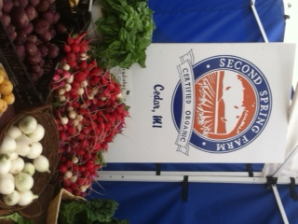

Goal:
To create awareness of the nutritional benefits of fruit and vegetables, thereby increasing participants’ fruit and vegetable consumption.

Core nutrition message:
Eat the recommended servings of fruit and vegetables daily (2.5 to 3 cups).

Participants will be able to:
- Discuss the benefits of eating various fruit and vegetables.
- Identify ways to incorporate more fruit and vegetables into their diets.

Background:
Many Americans do not consume the recommended amounts of fruit and vegetables. Eating the recommended amounts can help reduce the risk of certain cancers, heart disease, diabetes and high blood pressure. It can also help people maintain a healthy weight. Both fruit and vegetables are high in vitamins, minerals and fiber. Eating a variety is very important to ensure that people get all of the necessary nutrients.

What is Project FRESH?
Project FRESH is an educational program that provides participants with coupons to purchase locally grown fresh fruit and vegetables at participating farmers markets. The program plays an important role in helping families eat more fruit and vegetables. It also benefits local farmers by providing them with additional income through the redemption of the Project FRESH coupons.

3c.2. Progress in Achieving Goals
During 2014, WIC Project FRESH was offered to more than 8,300 participants throughout Michigan. In the next section we present a summary of the findings from WIC 2014 Project FRESH data which is collected through evaluation forms that MSUE instructors collected and submitted as of October 30, 2014.

3c.2.1. Socio-demographic characteristics
MSUE instructors reported that the WIC Project FRESH lessons were provided in 59 of 83 Michigan counties. From June to October 2014, WIC Project FRESH was delivered to more than 560 groups. A total of 8,245 participants received nutrition education from MSUE instructors and completed evaluation forms. Ninety-four percent of the participants were women. Of those who reported their ethnicity, 12% were Hispanic and 88% were non-Hispanic, while 13% were African American, 71% White and 16% selected other races.

3c.2.2. Visits to farmers markets
According to data collected, Project FRESH is the first farmers’ market experience for many WIC participants; 14% of participants reported that they hadn’t been to a farmers market before.
Based on the participants’ answers, as a result of attending the MSUE presentation, 95% indicated that they intended to buy fruit and vegetables at the local farmers market.

3c.2.3. Participation in Project FRESH and redemption of coupons
70% of the participants used ALL of their coupons last year. 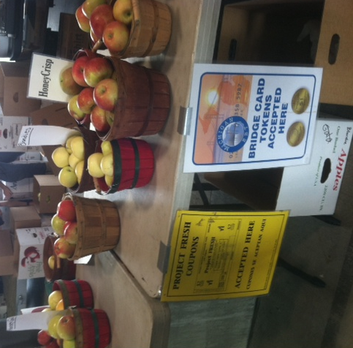
Participants reported their participation in Project FRESH during the last year and their experiences redeeming their coupons. Forty-four percent reported that they did not participate in Project FRESH last year.

Of those that participated, 70% reported that they used all of their coupons last year, and 13% reported that they did not redeem all of their coupons for variety of reasons.
Their most frequent responses for not redeeming coupons were:

- No time (12%)
- Working (21%)
- Hours of the market (11%)
- No transportation (17%)
- Poor selection of fruit and vegetables (10%)
- No market (2%)
- Lost coupons (13%)

3c.2.4. Intentions of healthy behavior change as a result of attending the WIC Project FRESH presentation
WIC participants who participate in Project FRESH became more aware of the importance of eating fruit and vegetables. Participants indicated that as a result of attending the MSUE food presentation workshop:
  - 95% will eat more fresh vegetables per day.
  - 95% will eat more fresh fruit per day.

3c.2.5. Concepts learned and awareness of the potential benefits of a healthy diet.
As a result of attending the MSUE food presentation workshop:
  - 92% of the participants reported that they learned new ways to incorporate more fruit into their meals and snacks.
  - 92% of the participants reported that they learned new ways to incorporate more vegetables into their meals.
WIC Project Fresh creates awareness of the benefits of eating fruit and vegetables.
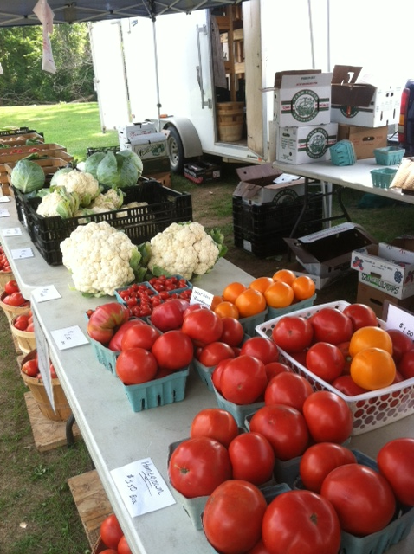and vegetables
  - 98% of the participants reported that they agreed or strongly agreed with the statement “Eating fruit and vegetables every day as part of a healthy diet may reduce your risk of certain types of cancer and various diseases.”

In summary, MSUE was able to reach a significant number of WIC participants with the Project FRESH nutrition education program. Participants from whom we were able to gather outcome data voiced their intention to increase healthy behaviors and to buy fresh fruit and vegetables at their local farmers market as a result of attending the WIC Project FRESH presentation.

4. Overall Assessment.
We were able to reach a significant number of adults with nutrition education in Michigan. Demonstrated improvement in knowledge and target behaviors was shown in participants who submitted outcome data. In general, our programs were effective in changing adult’s behaviors.

