4-H CAREER EDUCATION HANDOUT

NEFE High School Financial Planning Program

Help youth learn to manage money through the NEFE High School Financial Planning Program®. Use this FREE program to give high school youth access to sound money management skills and the financial planning process.

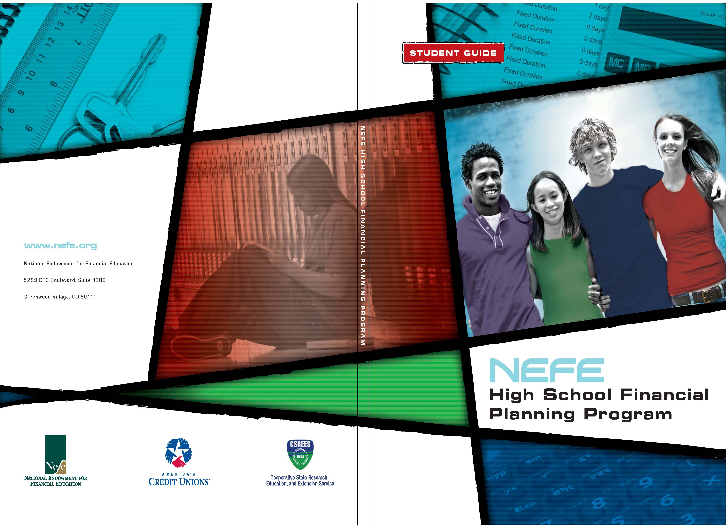

To order this curriculum, visit:
http://hsfpp.nefe.org.

To learn more about this program, contact:
Julie Chapin
Michigan State University Extension
160 Agriculture Hall
East Lansing, MI 48824
517-432-7608
chapin@msu.edu
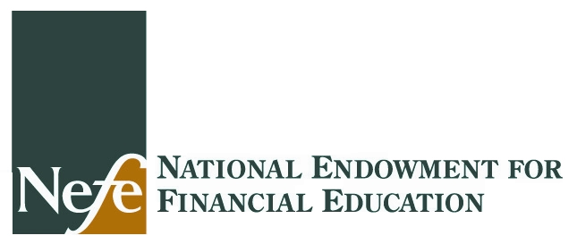
Unit 1 – Financial Planning: Where It All Begins
Unit 1 teaches the basics of financial planning, goal setting, needs and wants, and the financial planning process. As a result of this unit, youth will create a personal financial plan.
Unit 2 – Budgeting: Making the Most of Your Money
Unit 2 teaches youth about the basics of budgeting, sources of income and expenses, and the concept of pay yourself first. As a result of this unit, youth will construct a personal budget.
Unit 3 – Investing: Making Money Work for You
Unit 3 introduces youth to saving and investing. Youth learn about the time value of money, investment options, and the risks and rewards of investing. As a result of this unit, youth will propose a personal saving and investing plan.
Unit 4 – Good Debt, Bad Debt: Using Credit Wisely
Unit 4 introduces youth to the basics of credit. Youth will understand the process for applying for credit, what a credit history is, how to manage credit wisely, and the consequences of excessive debt. As a result of this unit, youth will identify a plan for handling credit and managing debt in their lives.
Unit 5 – Your Money: Keeping It Safe and Secure
Unit 5 covers the basics of financial services including savings and checking accounts and credit and debit cards. Youth will also explore identify theft. As a result of this unit, youth will demonstrate how to effectively use various financial services.
Unit 6 – Insurance: Protecting What You Have
Unit 6 introduces youth to strategies to effectively manage risk and how insurance is used to protect against loss. As a result of this unit, youth will create a personal insurance plan to minimize their personal and financial risk.
Unit 7 – Your Career: Doing What Matters Most
Unit 7 focuses on career choices and earning potential. Youth will explore how education and training can affect earning potential, and the costs associated with career preparation. As a result of this unit, youth will examine how a career choice and lifestyle affect their financial plan.

