
Cheboygan County
Cheboygan County Extension  870 S. Main, PO Box 70, Cheboygan, Michigan 49721-0070 |  | P: 231-627-8815  F: 231-627-8408 |  |  |  | E-mail: msue16@msu.edu  http://www.msue.msu.edu/Cheboygan
 |  |  |  |  | February 2008
Local farm tour an eye-opener for Cheboygan residents  A Smithsonian Institution exhibit titled, “Key Ingredients” shared part of the Cheboygan Area Public Library last fall, bringing more than just stories to the area; it also brought opportunity.  While the exhibit was here, Cheboygan County MSU Extension partnered with four local farms to showcase the diversity of food culture found right here in Cheboygan County.  On a crisp October morning nearly 60 participants from across the county boarded a tour bus for a guided tour highlighting local agriculture. MSU Extension partnered with Air Bear Travel, the Cheboygan Chamber of Commerce and the library to provide the tour, a DVD highlighting local agriculture and a box lunch.  The first stop was the Tracey Farm near Cheboygan, where the group was treated to a look at year-round greenhouses producing micro-greens, tomatoes and herbs. Don and Linda Tracey sell their organically produced produce to local restaurants and chefs.  The second stop was at one of Michigan’s oldest bottling dairies. Inverness Dairy milks just shy of 200 cows and supplies local groceries, schools and business across Northern Michigan and the U.P. The stop included tours of the milking parlor and the bottling plant and a refreshing sample of milk.  The third stop was somewhat historical. Many people regularly drive by the fields that comprised Northern Orchards and never realize that it was once the largest block of tart cherries in the world. Marty Andrews, son of the former owner, shared the story of the orchards, the types of cherries and other fruit grown and the impact of Northern Orchards on the local economy. Today, the fruit trees are gone, replaced by an aging jack pine plantation and small acreage housing development. |  |  |  |  | The final stop highlighted a little known and very unique farm--the Michigan Cranberry Company. This operation encompasses several hundred acres in eastern Cheboygan County and produces nearly 70 percent of the cranberries grown in Michigan.  The farm began 17 years ago as a pursuit of a passion by the Hugget family. Today, there are 150 acres of cranberry bogs that produce millions of pounds of cranberries annually. The tour group saw the flood harvesting process and took a tour of the cranberry processing facility.  The full-day farm tour allowed residents to experience the many types of agriculture represented locally by agricultural producers. The group unanimously supported the idea of making the farm tour an annual event.  Ben Bartlett, County Extension Director  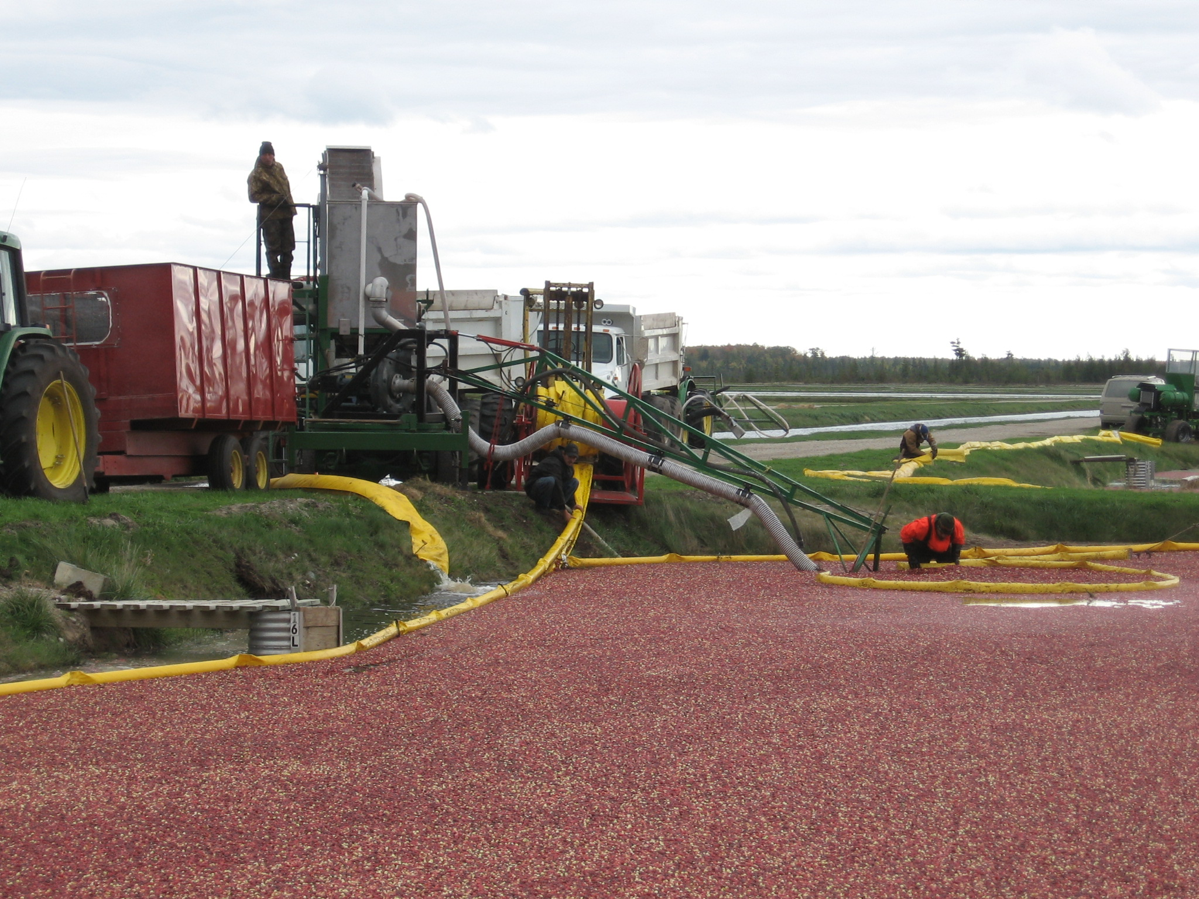  Flooding a cranberry bog as part of the harvest at Michigan Cranberry Company.
 | Michigan State University Extension helps people improve their lives through an educational process that applies knowledge to critical issues, needs and opportunities. Offices in counties across the state link the research of the land-grant university, MSU, to challenges facing communities. Citizens serving on county Extension councils regularly help select focus areas for programming. MSU Extension is funded jointly by county boards of commissioners, the state through Michigan State University and federally through the US Department of Agriculture. |  |  |  |  |  |  |  | 
Nutrition stories get Head Start students up and moving  Family Nutrition Program associate Mary Ellen Enos is a familiar face at Cheboygan County’s five Head Start classrooms.  She has made nutrition education for children in Head Start a priority. She read them books that are entertaining and encourage them to eat more fruits and vegetables and to exercise.  “Animal Action ABC” by Nancy Sheehan was the latest book Enos shared with her young learners. This “read and move” book shows children how fun and important it is to exercise and learn about action words like “arch” and “balance”.  Enos has worked in 12 Head Start classes since October, reaching 263 children with healthy lifestyle messages. The information she shares with them is also relayed to their parents, making the impact family-wide.  Patti Spinella, FNP Program Associate  Archery participation hits a new target  With a simple shift in program format, the Cheboygan County 4-H Archery Program increased its youth participation numbers ten-fold in the past year.  Previously, archery was offered in the traditional, year-round club format with families committing to participate in the club for a full year. Within that model, only three youths per year were actually completing the program.  During the 2006-07 4-H year, the format was changed to a 12-week series during the spring months of March through May. Twenty of the 22 youths who signed up completed the program.  In the 2007-08 4-H year, an after-school program has also been added, which has boosted the participation numbers another 50 percent. |  |  |  |  | These 11 new youth members in the archery program are from an economically disadvantaged community that was previously not served by this program.  “Our leaders put a lot of time and effort into making archery fun and safe at the same time. After learning shooting skills, the biggest thing we learned was good sportsmanship – people were always encouraging and willing to help. I’m more interested in hunting now that we got to do 3-D shooting,” said Kaitlyn, an 11-year-old first-year archery member  Looking forward, there is rising interest among adults to become certified archery leaders for Cheboygan County 4-H, lending hope for continuing the growth of this program.  Thirty youths, instead of three, are now involved in this physically and mentally challenging outdoor sport—it’s a huge success for Cheboygan County 4-H.  Tracy Meisterheim, CYF / 4-H Educator  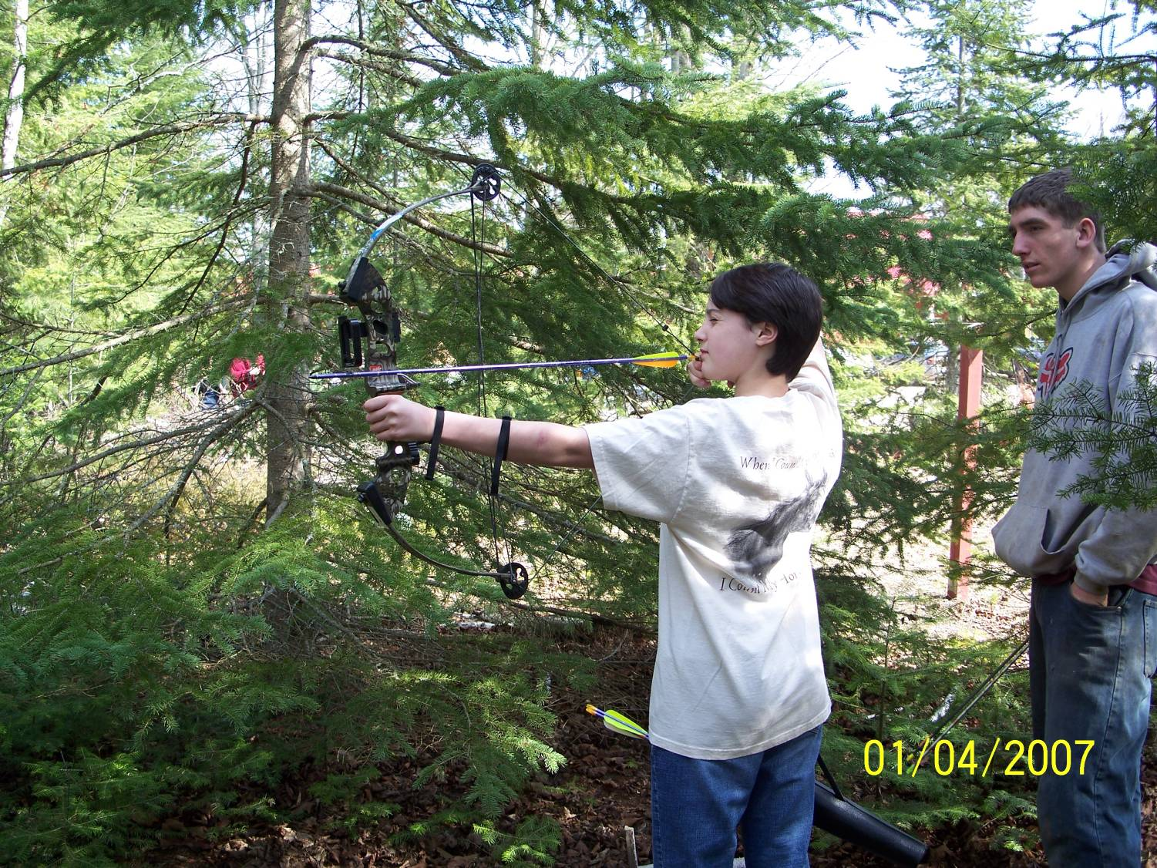  A young Cheboygan County archer takes aim under the watchful eye of a trained adult volunteer during a 4-H archery program event.
MSU is an affirmative-action, equal-opportunity employer. Michigan State University Extension programs and materials are open to all without regard to race, color, national origin, gender, gender identity, religion, age, height, weight, disability, political beliefs, sexual orientation, marital status, family status or veteran status. Issued in furtherance of MSU Extension work, acts of May 8 and June 30, 1914, in cooperation with the U.S. Department of Agriculture, Thomas G. Coon, Extension Director, Michigan State University, E. Lansing, MI 48824

