**COMPASS/MAP/Posting guide:**

**Guide for Department Staff**

**General questions/tips:**

1. **Q:** How do I initiate a Position Request form?

**A:** Within EBS, select the Unit Administrator tab. Then select Administrative Services. Go down to the Employee-Related Services section. For Faculty and Academic Staff select “Academic Position Request”. For Support Staff select “Staffing Request Post/Reclassify position”. Complete the appropriate form. Once submitted the form will go through department and account approval levels and then route to HR for approval. Once here the forms are reviewed and posted in COMPASS if appropriate.

1. **Q:** Regarding Guest User access

**A:** -the link to the guest user access to view is different than the normal COMPASS/MAP web address; for a guest to login into the guest COMPASS system, login in through this link using the guest user id and password given:

<https://jobs.msu.edu/userfiles/jsp/shared/frameset/Frameset.jsp?time=1402664360207>

1. **Q:** I am logged in as a guest user on a posting and can’t access the reference letters?

**A:** COMPASS does not give a way for guest users to view the reference letters for applicants. The staffing coordinator would have to print them out for the committee members.

Note: We are looking into our options to make it possible for guest users to see reference letters with a possible upgrade.

1. **Q:** Adding user access to COMPASS to view and approve postings (staffing coordinator, Department Head, Dean/AVP/Director, or Search Committee Chair):

**A:** To add access for approval levels the supervisor or staffing coordinator on the posting needs to contact HR by email with the following information:

-Person’s first and last name

-Net ID

-Type of access needed (ie: staffing coordinator, Department Head, Dean/AVP/Director, or Search Committee Chair)

-What org units the access is needed for. It helps to give both the org unit code and department name. (ie: 10070642-AVP Human Resources)

Note: * For FAS postings you can email Shannon Kemp directly or one of the FAS posting analysts, Bernadette Russell and Angela Hunt.

*For support staff postings email Talent Management at [TalentManagement@hr.msu.edu](mailto:TalentManagement@hr.msu.edu)

1. **Q:** I login into COMPASS, but I can’t see any postings?

**A:** When you login into COMPASS if no active postings appear you may need to change your default view. To do so go to Admin on the left and under that select Change Default View. Then change the view to the proper approval level (staffing coordinator, Department, and so on). Any active postings within the org unit approval should appear.

1. **Q:** I have completed all the Hiring information and the person is hired; why am I still seeing the posting in my queue?

**A:** The posting will still appear in your queue until the HR person who approves and enters the hires here in HR has finalized the hire in SAP and check and sent the form. At that point they will manually go in and change the setting to “EBS updated” which will remove the posting from queue.

**Support Staff:**

1. **Tip:** Write job postings information from class spec for job posting minimums; especially the education and experience time frames.
2. **Tip:** Post job with what you plan on paying the person in the position and if possible put a minimum or a pay range in the pay fields. This helps give applicants a better idea and in some cases can cut down the applicant pool to those truly interested.
3. **Tip:** Include information in the appropriate available fields rather than listing information in the comment section. The comment section is for additional information that is not covered, or does not have a field in the position request form already. A few examples:

-Off-date and flex information should be in the *Off-Date* field

-Work hours in the *Work Hours* field

-When a unit wants to request names and contact information for references - list that under the *Special Instructions* field

-When a work/writing sample is a REQUIRED document, include a brief description of what type of sample you are looking for in the S*pecial Instructions* field.

-Under the *Posting Salary Type* field for professional positions please either include the pay information as either “Salary Negotiable” or “Minimum Pay Rate”.

-For CT and other vacancies, the *Posting Salary Type* needs to include the minimum pay rate

-If a unit would like to include a “Working Title” for a professional position, please indicate in the *Functional/Working Title* field.

1. **Tip:** When working on a Reclass, look at the Class specs and work from the Class specs when filling out the Reclass request. If you are not sure, still submit the form and HR will work with it when it gets in. Often there is no way to know for sure if it is indeed a reclass, or will be approved, until the form is completely reviewed and the position is audited.
2. **Q:** What is the deadline for postings to be to human resources in order to be in the following Wednesday posting?

**A:** Position request forms must be to the human resources EBS inbox by NOON on Friday in order to be in the following Wednesday posting.

**Tip:** It helps to submit any forms a week early to ensure they make it through all the approval levels and to HR’s inbox by Friday at Noon.

1. **Q**: What is the pay for this position? Where can I find salary levels for a position based on pay? **A**: The pay for this position should be indicated in the description of the position. If there is none listed, it will be discussed during the hiring process. If it says “Negotiable”, the pay can be negotiated at a later time. If a figure is listed, this is not necessarily the exact amount, but rather the minimum for a position of this type. <http://www.hr.msu.edu/recognition/supportstaff/payrates.htm>
2. **Q:** Where can I look up job titles and descriptions?

**A:** <https://jobclassifications.hr.msu.edu/application/jobClassificationSearch.jsf>

1. **Q**: What does off-date/flex mean?

**A**: Off-date positions are those with an ‘end date’. At the time of acceptance of the position, an estimated ending or "off date" is given. This ending date is the latest date the employee is intended to work. It may be extended by written mutual agreement. Off-date employees hired for greater than nine months are designated "regular".

Flex positions are those that are hired under the conditions that the employee will not work year round. Typically, flex positions have 1, 2, or 3 months off during the year with no pay, but benefits will continue year round.

1. **Q:** Where can I find Union contracts?

**A:** <http://www.hr.msu.edu/documents/contracts.htm>

1. **Q:** Submitting a hiring recommendation; what are the steps?

**A:** Please see below

First, indicate which candidates were interviewed for this position. Click the “Change Status” Link

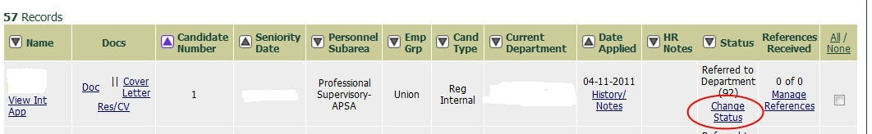

When the screen refreshes, use the drop down in the Status field to select “Interviewed.”

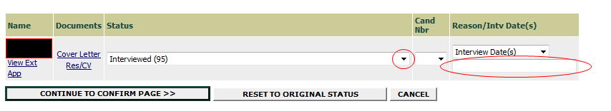

You will need to input the Interview date in the open field as shown above.

Next, indicate which candidate you want to hire. Click the “Change Status” link again for this individual.



When the screen refreshes, use the drop down in the Status field to select “Recommended for Hire”

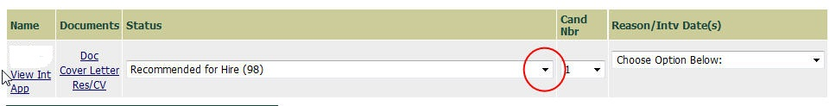

You must select a reason. Drop down the “Reason/Intv Date(s) field and select “Most Qualified/Most Senior Qualified.”

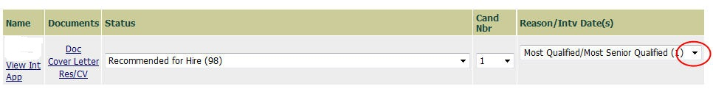

Now you can create the Hiring Recommendation. Click on the green “Hiring Recommendation” tab.



When the screen refreshes, click the “Add New Entry” button.

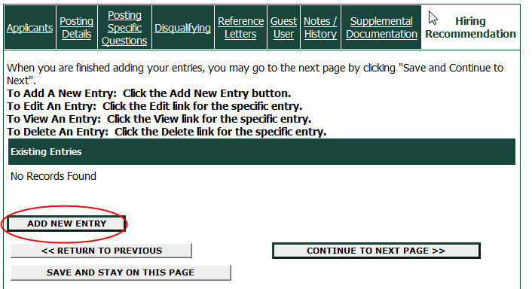

Now you can enter the hiring recommendation data. Complete all the fields with red asterisks and click the “Add Entry” button.

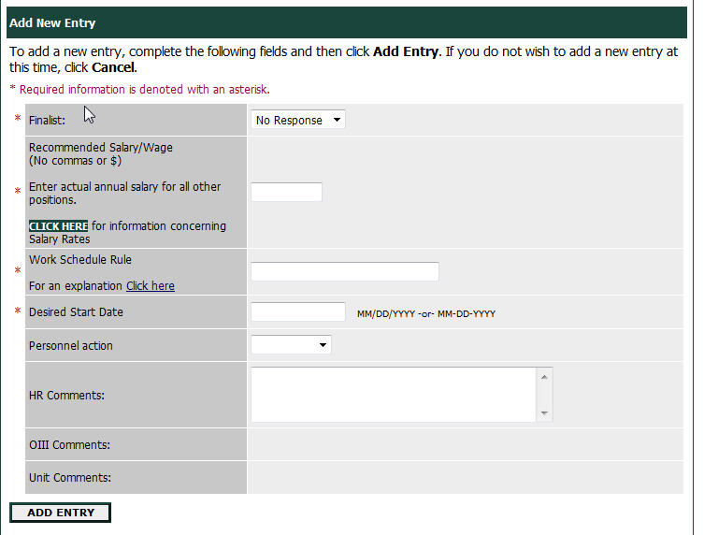

To submit for approval, first click the “View Posting Summary” button at the bottom of the screen.



Then select “Submit Hiring Recommendation for Review” and click the “Continue” button.

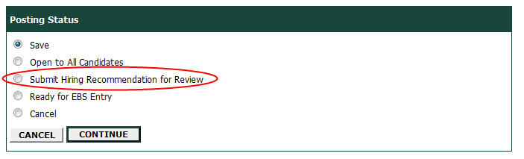

The hiring recommendation will then go to the analyst for review and approval.

1. **Q:** How do approvals work once a hiring recommendation has been submitted?

**A: -** Talent Management reviews the hiring recommendation to ensure proper procedures have been followed, that contractually required interviews have taken place, and that interview dates are indicated for all candidates interviewed. They also review the initial recommended salary to ensure it is in keeping with contractual obligations and institutional equity.

**-** If the posting has placement goals for Women and/or Minorities, The analyst reviews the applicant pool and if the recommended hire does not address the placement goal or if they cannot determine if he placement goal has been met, they forward to OIII.

**-**Talent Management waits for OI3 to approve the hiring recommendation (status 'Hiring Recommendation Approved by OIII) before proceeding.

**-** Talent Management makes final approval for internal hires (excluding temps/on-calls) by setting the status of the hiring recommendation to 'Ready for EBS Entry.'

**-** Talent Management makes final approval for external hires (including temps/on-calls) by initiating a criminal background check and setting the status of the hiring recommendation to 'Collect Hire Details/Schedule Orientation.'  An email is sent to the hiring department instructing them to have the external hire call the Solution Center to schedule orientation and to answer the background check email sent by HireRight.

1. **Q:** At what phase do you develop the Interview Committee?

**A:** The interview committee is really up to the department. HR recommends that the committee be diverse in backgrounds, knowledgeable of the position, and that it is kept consistent throughout all of the interviews for fairness to the applicants. Generally 2-3 people on a committee.

1. **Q:** When does OIII have to sign off/approve and how does this happen?

**A**: The analyst reviews the applicant pool and if the recommended hire does not address the placement goal or if they cannot determine if he placement goal has been met, they forward to OIII. Talent Management waits for OI3 to approve the hiring recommendation (status 'Hiring Recommendation Approved by OIII) before proceeding.

**Faculty/Academic Staff Job Postings**

**General notes on FAS postings:**

Links to assist with FAS job searches and postings can be found at:

<http://www.hr.msu.edu/documents/facacadhandbooks/aa_searches/index.htm>

1. **Tip:** Applicant status’ should remain “under review by Search Committee” until the posting closes.
2. **Tip:** Use Tenure System Verbiage; NOT “Tenure Track”.
3. **Tip:** Make sure Degree requirements match the minimum qualifications.
4. **Tip:** Re: Waivers; OIII prefers that Summary rationale for a waiver request come with the Position Request form.
5. **Q:** On the Academic Position Create Request there is a wizard question “open rank position?” what does this mean?

**A:** This should only be selected if the position rank/title being created will depend on the applicants qualifications and credentials. Ie: Assistant Prof/Associate Prof/Professor.

**A:** If this is the case then you would select yes to the wizard question



and the highest possible rank/title in the Organization Assignment section under Job Title.

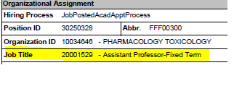

and then put the possible lowest possible rank/title or ranks/titles in the other ranks/Titles section of the form

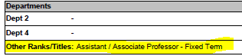

1. **Q:** At what phase do you develop the Search Committee?

**A:** When discussions are under way to fill a new or vacant position, a search committee should be formed or appointed. More information on the Search Committee can be found in the Composition of Search Committee document at <http://www.hr.msu.edu/documents/facacadhandbooks/aa_searches/searchcommittee.htm>

Duties of the Search committee and how their role plays a part in the hiring process can be found at 4.3 Charge to the Search Committee - Affirmative Action Searches <http://www.hr.msu.edu/documents/facacadhandbooks/aa_searches/charge.htm>

1. **Q:** How do I close an open until filled posting?   
    **A:** Correspond with an analyst (Angela [huntaj@hr.msu.edu](mailto:huntaj@hr.msu.edu) or Bernadette Russell), or Shannon Kemp at [hickssh1@hr.msu.edu](mailto:hickssh1@hr.msu.edu).

Note: if there is a shadow posting involved it is helpful to mention in the email you would like the applicant pool copied over to a shadow posting and to reference the shadow posting number when closing a live posting.

1. **Q:** If a posting is closed, and after interviewing, it is determined that more applicants are needed, can the posting be reopened?

**A:** Yes; it must be re-opened for a minimum of 2 weeks. Exceptions to the 2 week period must be discussed with Angela/Bernadette (analysts) and depending on the circumstances MAY be approved.

**Note:** When reopening an open until filled posting, the applicant review date does not change.

1. **Q:** When does OIII have to sign off/approve and how does this happen?

**A:** OIII needs to approve the applicant pool BEFORE Interviewing begins. See steps of approvals:

-Posting closes first.

-Applicants get identified for Interview

-Staffing coordinator sends pool to Chair, The chair sends pool to the Dean, and the Dean sends pool to OIII.

-OIII approves list and sends back to Search Chair.

1. **Q:** Re: Reference letters. How does COMPASS handle letters of reference?  Is it the case that only the applicant can upload documents into COMPASS? Is there a way for letter writers to upload letters of reference directly?

**A:** Part 1: On the Position Request form there is a wizard question “Require letters of reference?”; if when creating the position request form the initiator selects yes to this question, and then fills in the required number of letters needed and says “yes” to “Activate COMPASS to collect?” the COMPASS system will automatically require applicants to enter the names and email addresses of references (number determined based on what number is required on the position request form) when applying.

Part 1: Then after the applicant finishes applying the system will automatically send emails to the references emails entered by the applicant. The applicant will never be able to see the reference letters, and the referee will then upload them directly to the applicant’s application for the Search Committee to view. Even after the referee has uploaded the reference letters, the applicant will not be able to see the letters attached to their application within the system.

*Note: If “Activate COMPASS to collect?” is not selected as yes, the system will not initiate this process.

1. **Q:** Submitting a Hiring Recommendation; what are the steps and how do approvals work?

**A:** -Search Committee interviews applicants and determines who to hire.

-Once applicant has accepted offer the staffing coordinator can start the Hiring recommendation steps. See below for these steps:

First, indicate which candidates were interviewed for this position. Click the “Change Status” Link



When the screen refreshes, use the drop down in the Status field to select “Interviewed.”You will need to input the Interview date in the open field as shown above.

Next, indicate which candidate you want to hire. Click the “Change Status” link again for this individual.

When the screen refreshes, use the drop down in the Status field to select “Recommended for Hire”



You must select a reason. Drop down the “Reason/Intv Date(s) field and select “Most Qualified/Most Senior Qualified.”



Now you can create the Hiring Recommendation. Click on the green “Hiring Recommendation” tab.



When the screen refreshes, click the “Add New Entry” button.



Now you can enter the hiring recommendation data. Complete all the fields with red asterisks and click the “Add Entry” button.



To submit for approval, first click the “View Posting Summary” button at the bottom of the screen.



Then select “Submit Hiring Recommendation for Review” and click the “Continue” button.



Then Hire paperwork is submitted via EBS.

**Cluster Hires:**

1. **Q:** What is a “Cluster hire”?

**A:** Cluster Hire is when a dept has one “live” posting that applicants apply for; but have 1 or more identical duplicate postings that are “shadow” postings to the live one. Applicants only apply to the live posting, and then HR copies the applicant pool from the live posting, to a shadow posting. This makes it so applicants can continue to apply for the job, but only has to apply once instead of numerous times for the same “job”. It enables the department to get a good applicant pool to fill more than one position at the same time. The “shadow” posting continues through normal approval interview process while the live one continues to accept applicants for that position and any other shadow postings if they exist.

Overview of terminology:

-Live posting-> The posting that is created for applicants to actually view and apply for. This posting should not be closed until all “shadow” postings are closed and can stay open until filled to keep accepting applicants.

-Shadow posting (COMPASS name is pool posting-> The additional posting created to be filled based on the applicant pool on the “live” posting, but that is not out there for applicants to actually see. These are the postings that HR copies the applicant pool to as the department wants to interview candidates. These will not be visible to departments until they are closed by HR.

Process over view:

1. To initiate a cluster hire, a department will need to submit an Academic Position Create Request form indicating the number of positions needed.
2. Once the APCR is received and approved in Human Resources, your positions will be created and posted in COMPASS. **One main posting (live)** will be created that will remain open until all positions are filled. The department will be able to view this posting at all times and have the same accessibility as they normally would.
3. A **shadow posting** (or pool posting) will be created for each additional position requested. These postings will not be visible to the department at the time they are created. They also will not be visible to applicants.
4. When the department is ready to submit an Interview List for review, they will need to contact Human Resource analysts (Angela or Bernadette). Shannon Kemp will then copy the pool of applicants from the main posting and import that list to a shadow posting.
5. HR will then set that shadow posting to close on that date. At midnight, the shadow posting will close and be changed over to a ‘closed status.’ The posting will then be visible by the department the following morning after it closes. **Take-away note:** A department will not be able to submit the Interview List for review until the day after they contact HR.
6. Once a department is able to view the “shadow posting,” the regular COMPASS workflow processes will resume with that posting.

General Notes:

-If you close the “Live” posting before the applicant pool is copied it can inhibit the copying of the pool.

-A reminder, do not change live posting applicant status’ until the posting is closed. If you recommend a hire on the “Live” posting it makes all other applicants inactive, and thus they are not able to be copied to any “shadow” postings easily. Please make sure to copy pool to any shadow postings before making Hire recommendations on the “Live” posting.

**FAS posting Interview List approval phase:**

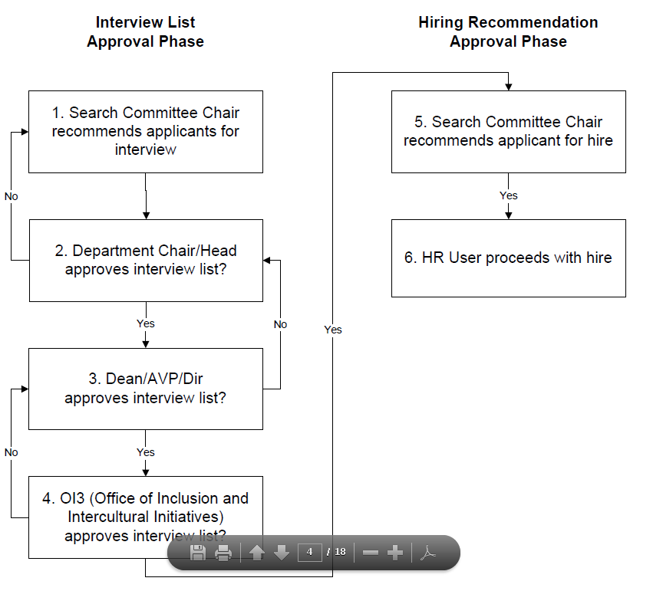

**Guide for applicants**

**Applying**

1. **Q**: Do you have a print out of the jobs available at MSU?

**A**: All of the jobs available at MSU are accessible via <https://jobs.msu.edu>. If you are looking to work for a specific department, you may want to consider contacting their Human Resources office or check on their website.

1. **Q**: How do I apply to a job at MSU?

**A**: The first step in applying is to create a profile online. To do this, go to jobs.msu.edu and click “Create Application/Profile”. (HR Toolkits on this process are available at: <http://www.hr.msu.edu/toolkits/prospective.htm>) Once you have created a login and entered all your personal information, you can search open positions by job title, department, employment type, etc...

1. **Q:** I want to apply to a job but I don’t see it on the website.

**A**: All jobs that are available at the current time are posted on the website. If you are interested in being notified when a certain position becomes available, you can create an email notification on the home page of the website. All positions are posted Wednesdays after 1pm.

1. **Q:** Who do I address my cover letter to?

**A:** All cover letters and supplemental documentation can simply be addressed to “To Whom It May Concern.”

1. **Q**: How do I create a job application?

**A**: To create an application on the website, first go to jobs.msu.edu. After arriving at the homepage you will find a link that says “Create Application/Profile.” After clicking this link, you will be asked what type of application to create. If you are a current university employee, you are eligible to create an internal application. If you are looking for a faculty or academic position, you are to create a faculty/academic profile. If you are not currently employed by the university and are seeking support staff positions, you can select the external application. You will then be prompted to create a login, followed by entering all your personal information. (HR Toolkits on this process are available at: <http://www.hr.msu.edu/toolkits/prospective.html>)

1. **Q**: I forgot my username/I lost my password. Can you send/reset it?

**A**: If you forgot your password, you can click the “Forgot my password” link on the website and answer the designated security question, or I can manually reset it. If you need it manually done, I will need your full name and the last four digits of your social security number. After I reset your password, your new temporary password will be your username. Once you login, you will be asked to create a new password.

If you need your username, I will need your full name and the last four digits of your social security number. If your social security number has not been entered in your profile thus far, I will need some other type of personal information to verify that this is you.

1. **Q**: How do I delete, add, or replace a document on a posting I am applying for?

**A**: Once you have applied your profile to the posting, you can attach any documents you feel should be considered in your application. Some postings will require a resume and/or cover letter, while others will not. To add these documents, you will need to navigate to your profile and find the posting you are applying for. Once you have done this, there will be a link to upload these files. **Please note** that there is a 2MB limit on each document. Documents must be in PDF format.

1. **Q:** I attached the wrong attachment (ie: resume, cover letter, transcript, writing sample) when applying for a posting and finished applying before I realized it. Now I don’t seem to be able to make any changes or replace what I uploaded. Is there away to replace/delete attachments to a posting once you have applied?

**A:** Yes, if the posting is still open. You can email any attachments that you need to add or replace to [records@hr.msu.edu](mailto:records@hr.msu.edu) and HR will update your application for you. Please note, when you email please make sure to state what name you applied under, and what posting number it was for to ensure your documents get added to the correct posting.

**\*\*note to HR staff:** If the posting is already closed we are NOT able to replace any attachments.

1. **Q**: Am I eligible to apply to internal postings?

**A**: Only university employees are eligible to apply for internal postings.

1. **Q**: Can you help me with my online application? I’m not good with computers/having trouble applying.

**A**: Can assist you over the phone, or you have the option to come into the Nisbet building and work on our computers in the lobby of suite 110. Someone can walk you through the process and answer any questions you may have at that time.

1. **Q**: The file size of my document exceeds the 2MB limit. What do I do?

**A**: All documents need to be compressed to meet the 2MB limit.

**Position Questions**

1. **Q**: What is the pay for this position?

**A**: The pay for this position should be indicated in the description of the position. If there is none listed, it will be discussed during the hiring process. If it says “Negotiable”, the pay can be negotiated at a later time. If a figure is listed, this is not necessarily the exact amount, but rather the minimum for a position of this type. <http://www.hr.msu.edu/recognition/supportstaff/payrates.htm>

1. **Q**: What is the closing date of the posting?

**A**: The closing date for this posting should be listed in the position description. If you are having trouble locating the closing date, an Human Resource staff member can assist you in locating it.

1. **Q**: What does internal and external mean?

**A**: “Internal” indicates that the position is open to university employees only. “External” would be open to both university employees and non-university employees.

1. **Q**: What does off-date/flex mean?

**A**: Off-date positions are those with an ‘end date’. At the time of acceptance of the position, an estimated ending or "off date" is given. This ending date is the latest date the employee is intended to work. It may be extended by written mutual agreement. Off-date employees hired for greater than nine months are designated "regular".

Flex positions are those that are hired under the conditions that the employee will not work year round. Typically, flex positions have 1, 2, or 3 months off during the year with no pay, but benefits will continue year round.

**Reference Letter Providers**

1. **Q**: I got an email to provide a letter of reference for XXX. Where do I upload it at?

**A**: A link should have been included in the email that you received. Once you click the link, you will be taken to a site where you can upload the letter. If you’d like, I can help upload the letter for you. I just need the applicant name, and the posting # included from the email you received.

1. **Q**: How do I see the posting information that I’m recommending the applicant to?

**A**: You will receive an email from MAP with a link that will take you to a description of the position which will include the position’s title, department, and description.

1. **Q**: Can the applicant see my letter of reference when I upload it? Is it confidential?

**A**: Applicants are not able to view any letters that you submit to their application. All letters of reference are confidential.

1. **Q**: I think I uploaded the letter of reference for XXX . Can you verify you received it?

**A**: Yes, I can check this for you. First I will need the applicant’s full name and posting number.

**Applicant Status**

1. **Q**: I’m calling to check the status of my application (or why is it taking so long).

**A**: If the status says “Referred to Department” - let the applicant know that the hiring unit is still reviewing applicants. Please be sure to check your application for any updates.

1. **Q**: What does (applicant status) mean? (i.e. “Referred to department” or “Not qualified”)

**A**: Referred to Dept: At this point, your application has made it through the initial screening process at Central HR. Your application has been forwarded for further review at the department level. You can expect to hear from them as they advance in the hiring process.

Not qualified: (Depends on reasoning—review if any notes/comments are provided in COMPASS by the analyst on the posting. Provide that information to the applicant. If there are further questions, refer to analyst)

1. **Q**: Why was I not referred? (if analyst has noted why)

**A**: Review if any notes/comments are provided in COMPASS by the analyst on the posting. Provide that information to the applicant. If there are further questions, refer to analyst.

1. **Q:** How do I make my application certified so I can apply for positions?

**A:** filling out application there is a certification statement button. She needs to click the certification statement button, continue, and confirm on the final pages of the application to save the information entered. If she closes this screen, close your Internet browser, or lose Internet connection before clicking "confirm" on the final page, the application will not be saved and must be started over.

1. **Q:** My application status says “Incomplete Application”; what does this mean?

**A:** This status means that you did not finish completing and submitting your application and therefore have not officially applied for the posting. Generally it is because the application was not certified by the applicant. See question 22 for directions on how to certify an application.

1. **Q**: I didn’t get picked for a job and it says to contact HR.

**A**: Let me look up the HR professional assigned to this posting and I will have you speak with them.

1. **Q**: I get a message that says I need to review and certify my application. What do I need to do?

**A**: A system change has been made a change to our application since the last time you applied. Please review each screen of your application and verify the information is correct, and each question is responded to. Save and continue to the next screen until you have reached the summary screen. Click on continue, and then confirm. Your application is now certified.

**Typing/Assessment Test/CAT testing**

1. **Q**: Where do I go to take the test (typing, CAT, Excel, Word, PowerPoint, Database)?

**A**: To take one of the office assessments or the typing test, you can come into the Nisbet building in suite 110.

1. **Q:** What types of testing are offered?

**A:** Typing, Excel, Word, PowerPoint, Database (Access). Any requirements will be listed on the postings.

1. **Q**: What are the tests I have to take?

**A**: If you are trying to qualify for Temp Services, you need to take Microsoft Office assessments in PowerPoint, Word, Excel, and Access. Each test runs approximately 30 minutes. You will also need to take a 3 minute timed typing test. If you are simply taking a typing test to qualify for a posting, you do not need to take the Microsoft Office assessments.

If you are applying for a posting on MAP, any testing requirements will be listed on the posting. You are welcome to take them and have on file as reference and as backup to resume experience.

1. **Q:** What is CAT testing and where does it get taken?

**A:** CAT stands for Computer access and training and is part of the Computer Access and Training initiative and is a hands-on computer skill evaluation of general computer/internet skills that has to be taken by employees being hired into labor positions (ie: service maintenance, operating engineers, Service workers).

Note:Employees must pass the evaluation, but are given extra training if needed.

1. **Q**: What times can I come in?

**A**: The assessments are available on a walk-in basis. We generally stop testing around 4:30pm. We are open at 8am Monday through Friday. Make sure to give yourself enough time if you need to take the Microsoft Office assessments, but you are not required to do them all in one day.

**Note**: Required testing must be done by the end of the day the posting closes (for support staff that is generally Tuesday.)

1. **Q**: What is my typing score on file?

**A**: A human resource staff number can look that up for you. What is your first and last name? (search applicant profile, select ‘Edit Application’, scroll down to the bottom)

1. **Q:** Recording assessment scores on applications (Microsoft office /typing scores)

**A:** If these pertain to postings they’ve already applied to, that are still open, then the process for attaching the most recent application should be followed.

*\*The following questions should be referred to an analyst in Talent Management*

1. I keep applying and applying and I never get calls back. Why can’t I get a job?
2. How do I get a job at MSU? What are some tips/pointers?
3. Further explanation of applicant status codes, or why someone was not referred
4. Re-opening a posting