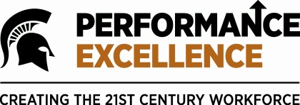

Examples of Competency-Based Goals

Leadership & Service
- Complete all of your staff performance evaluations, including documented goals and professional development plans, by the established due date
- By [DATE], identify a process that you feel could be improved and create a process improvement plan to present to your supervisor

Work Quality & Efficiency
- Create a knowledge base of the major business functions that you perform, documenting all current procedures by [DATE]
- Throughout the year, track all rejected transactions/forms and identify and document the reason for rejection; identify and document the proper procedure moving forward to avoid future rejections

Teamwork & Engagement
- Identify, engage and collaborate with another CED/MSU employee on an assigned project, process improvement, or other business function this year
- On a weekly basis, document your efforts in reaching out to a colleague to ask if they need assistance with any project(s) or workload

Communication & Outreach
- By [DATE], develop a process to regularly share information, ideas, and solutions amongst your business team; discuss the identified process with your supervisor and prepare to implement
- By [DATE], identify and develop a plan to support your team in improving external communications with one of the following: your department, the College of Education, Michigan State University, the local community, prospective students, nationally, globally, or another related constituent.

Customer Focus & Service Excellence
- Respond to all voicemail and email messages within one business day of receipt
- By [DATE], develop a process to assess the service you provide throughout the year to your customers; discuss the identified process with your supervisor and prepare to implement

DRAFT 02.23.16

