The Michigan Department of Agriculture and Rural Development recommends closing the gates to the pig barn after pigs have been at a fair or exhibition for 72 hours.

The following signs can be used to help the public understand why we are restricting access. Feel free to modify based on your show times and schedule.

Reducing stress and keeping pigs cool helps keep pigs healthy. Closing the gates is a preventative measure to ensure pigs are getting the best care, while reducing the amount of interaction the public has with the pigs during this crucial time for pig health.

The gates are closed today:
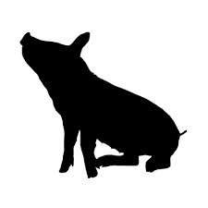
Our Pigs Need Time to Relax

The gates are closed today:
it’s HOT outside and we’re keeping the pigs cool.
The gates are closed today:
Our Pigs Need Time to Relax
The gates are closed today:
our pigs need to relax.
See them at the pig show
on DAY XX:XX!

