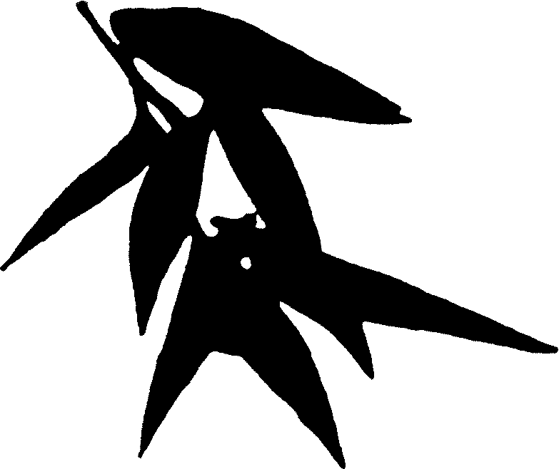
4-H Children’s Art Exchange
Michigan, United States of America and
Shandong Province, People’s Republic of China

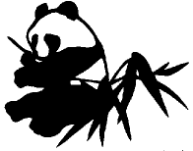


4-H Youth Development
Michigan State University Extension
Children, Youth, Families and Communities

Acknowledgments
This material was written by Betsy McPherson Knox, program leader and art exchange coordinator, CYFC/4-H Youth Development, and Jerry Catania, Ph.D., art educator and arts consultant. The design and illustrations were done by Marian Mahler Reiter, graphic artist, CYFC and ANR Communications. Editing was done by Michelle Rabidoux. Chen Jian, Ph.D. candidate, Michigan State University, translated and interpreted the Chinese children’s paintings. Secretarial support came from Sharon Reed and Heather Freeman. Student art support was provided by Michelle Laforgia and Shawn Bates. Additional assistance came from Liz Hausserman and Judy Reynolds, 4-H volunteers, and Jenett Patrick, elementary school teacher. This project was made possible by support from the W.K. Kellogg Foundation.
The updated version was edited by Patty Adams, CYFC, and designed by Nikky Pulling and Elaine Bristol, student graphic artists, CYFC.

How to Use This Material
Contents:
- How to Use This Material
- Acknowledgments
- Part I: Introducing the Chinese Children’s Art
- Part II: Talking About the Chinese Children’s Art
- Part Ill: Creating a Painting or Drawing
- Part IV: Mounting and Displaying Your Children’s Art
Reference Sheets:
- A Few Chinese Words
- Art Materials
- Common Problems Encountered When Doing Art Projects With Children
- Art Labels
- Parent or Guardian Authorization
- Evaluation
- Checklist
- Descriptions of Pictures
Additional Kit Materials:
- Chinese children’s pictures
- 4-H Children’s Art Exchange Poster
- Crayola Dream-Makers Ill Guide
- Laminated descriptions of the pictures
- Laminated 4-H Children’s Art Exchange Information Sheet for current year
- Laminated Kit Inventory

The goals of the Michigan 4-H Children’s Art Exchange project are to help children in Michigan and in Michigan 4-H’s partner province, Shandong, of the People’s Republic of China, better understand and appreciate one another’s culture, and to give Michigan children an opportunity to create their own artwork.
Each 4-H Children’s Art Exchange teaching kit consists of 9 to 10 original pictures by Chinese Children. Each kit, therefore, is a collection of one-of-a-kind pictures. Please take care of the pictures, as they are a gift to Michigan 4-H Youth Development. If the protective wrapping on a picture becomes damaged, return the entire kit to your county 4-H office for repair before you pass it on to the next group. The Children’s Art Exchange teaching kit also includes this study guide, a Crayola Dream-Makers III Guide, a 4-H Children’s Art Exchange Poster and laminated descriptions of the pictures.
This study guide plays an essential role in providing the best possible global and arts education experience for your children. You will find it very helpful to read through this guide and the reference sheets before working with your children. This project is designed for kindergartners through sixth graders, although older children are welcome to participate.
Experiential learning (facilitated learning through doing, reflecting and applying new understanding and knowledge) is used in this guide. The questions asked in Part II and Part III are critical to deepening and broadening your children’s art exchange with China experience.
Part I of this guide introduces China and the Chinese children who have sent their pictures to Michigan. The pictures were sent by children between the ages of 3 and 14. Most of the art work, however, was completed by 5- to 8-year-olds. Their art is extraordinary for such young children. These children have been selected from hundreds of Chinese children to receive after-school and weekend painting classes. In this special art setting, most of the children had extensive practice in painting. High quality paper, paints and brushes were provided for each child as well. Chinese children traditionally learn to write their language with a brush. Because of this, using a paint brush can be as comfortable and natural for a Chinese child as using a pencil is for an American child. This dexterity is beautifully evident in all the art in the 4-H Children's Art Exchange kits.
Part II of this guide will help you talk about the Chinese children’s art with your children. Each picture has a story, an idea, a feeling or a dream to share. Every piece of art becomes a visual letter to your children about life in China, as depicted by another child. Ultimately, your children will see many similarities between their Chinese counterparts and themselves. Before conducting Part II with your group, read the Reference Sheet: Descriptions of Pictures. Understanding the content of each picture will help you guide a discussion with your children. All the pictures have been identified in their descriptions as belonging to one of three Chinese painting styles. The Chinese have used the traditional Chinese brush painting style for thousands of years. Modern style Chinese painting is a style that has evolved during the 20th century, with countries outside of China having a major influence. The third style is a mix of traditional brush painting and modern styles.
Part III helps you lead your children through a visual arts experience. This guide is “user friendly”; you do not need to be an art teacher, or an artist, or have an art background. However, you do need to be willing to let your children experiment, be messy, have fun, and express their own thoughts and ideas with paper and paint, crayons and pencil.
After your children have produced their own works of art, Part IV provides directions for mounting and displaying their pictures. You can host your own art exhibit by combining the Chinese and American art. Then encourage your children to submit their pieces of art to 4-H Youth Development at Michigan State University for consideration for the 4-H Children’s Art Exchange to China.
PART I:
Introducing the Chinese Children’s Art
Objectives
• To learn about the Chinese children who created the pictures.
• To learn where China and the United States are located on a globe or map.
Materials:
• Chinese children’s pictures
• 4-H Children’s Art Exchange Poster
• Globe or world map
Time:
About 15 minutes
About China and the Chinese Children
Hang or prop the Chinese children’s pictures in numerical order in the room. Be sure that all the children can see the pictures. Hanging the artwork is the best way to view it, but leaning the pictures against the wall will work fine. Prop the pictures as straight up and down as possible to eliminate glare. The Chinese children’s pictures have Velcro “hook” fasteners on the back, and are ready to hang on a “loop” display unit or on “loop” tape strips. Do not use tacks, pins, staples or nails to hang the pictures. You can use pushpins on the edges of the pictures to mount them on a bulletin board.
Tell the children that most of the pictures in the room were done by children aged 5 to 8 who attended an after-school arts program. Explain that all these boys and girls live in a country called the People’s Republic of China. For younger children, put the words “China” and the “United States” on the chalk board or on a large piece of paper. Using a world map, show the children where the People’s Republic of China and the United States are located. Explain that China and the United States are separate countries. Older children may be able to identify these countries on the globe for you. Point out the oceans and land masses that separate the two countries.
Point out the photographs of the two Chinese children on the 4-H Children’s Art Exchange Poster. Read their names. Explain that these children have painted two of the pictures; point out their pictures. Explain that 200 children’s pictures were sent by ship from China to the United States, rolled up in three small bundles. These bundles traveled for 2½ months over 7500 miles to reach Michigan.
Older children may be interested in knowing that the pictures originated from Chengdu (chung-dü), the capital of Sichuan (ss-chwan) Province. The 4-H Children’s Art Exchange Poster identifies Chengdu, Sichuan, Binzhou and Shandong. Tell the children that a province in China is like a state in the United States. Remind them that they live in the state of Michigan, and that the capital of Michigan is Lansing. Tell them that Michigan’s largest city, Detroit, has around 1 million people, compared to more than 10 million people in Chengdu. Since 2003, Shandong has been Michigan 4-H’s Partner Province.
Part II:
Talking About the Chinese Children’s Art
Objectives:
• To discover painting and drawing as a way to communicate thoughts, ideas and feelings.
• To learn how to look at and talk about pictures.
• To learn about China as painted by Chinese children.
Materials:
• Chinese children’s pictures
• Reference Sheet: Descriptions of Pictures
• Reference Sheet: A Few Chinese Words
Time:
About 45 to 60 minutes
Communicating Through Art
Ask the children if they were to hear Chinese words, would they understand what was said? Would they be able to read something a Chinese child had written to them in Chinese? How can a Chinese child talk to a child in the United States? Does “talking” always have to be with words? Are there other ways that children can tell us about themselves—about their activities, their homes, their friends, and their ideas and feelings?
Allow the children some time to think about and discuss ways people communicate or “talk” without words. Tell the children that the Chinese children’s art is like a letter to them in pictures, rather than a letter in words.
What the Pictures Say to Us
Looking at pictures and talking about what they mean can be a lot of fun for children. Children often will comment enthusiastically on, and ask questions about, several pictures all at once. The discussion will be less confusing if you encourage the children to focus on one picture at a time.
Ask the children to choose a picture they would like to discuss. Allow them time to choose. Ask one child to explain his or her decision. Ask other children to comment on the same picture. Use the questions that follow to encourage thought and discussion.
- What is happening in this picture?
- Who do you see in the picture?
- Do you like this picture? Why?
- Do you dislike this picture? Why?
- What did the Chinese child who painted this picture want to tell you?
- What feelings do you have when you look at this picture?
- Do the colors used in the picture make you feel any special way?
- What do you see in this picture that is similar to things in your life?
- Would you ever think of doing a painting or drawing like this one?
- How are the people drawn? The trees? The animals? The flowers?
- How do you think the picture was made? What art materials are used in it?
When children ask you a question about the pictures, give the question “back” to the children. This means to encourage the children to answer each other’s questions. After the children have run out of questions and comments on a picture, read about that picture in the Reference Sheet: Descriptions of Pictures.
Then, move on to the next picture and begin the discussion process all over again. Ask the children to choose another picture they would like to talk about, and pick one child to explain his or her choice. Be mindful of the time spent on each picture. Allow enough time to cover all of the pictures. Naturally, some pictures will take a long time to explore fully; others will require only a brief discussion.
An explanation of the Chinese writing that is found on several pictures is given in the Reference Sheet: Description of Pictures. Each kit has one picture description that explains briefly the Chinese language and the meaning of each Chinese character (word, symbol or sound) found on that picture. Many of the pictures are signed by the artist. Usually, the signature reads from top to bottom, and includes the child’s name in characters one and two, and the child’s age in character three. Characters four and five mean “years” and “painted by,” respectively. For children interested in learning and identifying the Chinese characters for the numbers one through ten, “years” and “painted by,” use the Reference Sheet: A Few Chinese Words.
PART III:
Creating a Painting or Drawing
Objective:
For each child to create a painting or drawing.
Materials:
• Art materials
• Reference Sheet: Art Materials
• Crayola Dream-Makers III Guide
• Reference Sheet: Common Problems Encountered When Doing Art Projects With Children
• Reference Sheet: Art Labels
• Reference Sheet: Parent or Guardian Authorization
Time:
About 60 minutes
Selecting Art Materials
Encourage your children to use large pieces of paper. Large, bold paintings or drawings will more likely be noticed in an exhibit.
Do not have your children make three-dimensional art work as this type of art cannot be mailed to China. For more information on selecting art materials, see the Reference Sheet: Art Materials, in the back of this guide. The “Crayola Dream-Maker’s III Guide” will also be helpful in choosing art materials.
Setting Up the Art Room
The art space should be large enough to give the children room to work on large pieces of paper. This space should have a smooth work surface. Floors can be used, including hallways or gymnasiums (in a school setting). Cover the work surface with lots of newspaper. Carpeted surfaces covered with large pieces of cardboard will also work. Plan a space where the paintings can be spread out to dry, because sometimes paint takes hours to dry. Thicker paint may have to dry overnight. If the paint is not runny, paintings can be hung on a clothesline. Be sure the paintings are dry before stacking them. Before the art project begins, have all the art materials out at a supply table.
Beginning the Art Project
Tell the children that they will be painting (or drawing) a picture for Chinese children their own age. Just as the Chinese children “talked” to them with their paintings, they will be able to share their thoughts, ideas and feelings with the Chinese children. Their pictures can be about things they like to do, such as playing basketball, ice skating, seeing movies or cooking. A picture can also be about things they would like to show a friend from China, such as their school, home, family, friends and pets. Suggest that they paint a picture about a special wish or a dream they have. Many children in China would like to get to know children in Michigan. Since most people from Michigan can neither speak nor write Chinese, we can send drawings to “talk” to the Chinese children. These pictures can be called “visual letters.”
Tell the children that it is okay to use the whole sheet of paper, and that it is okay to paint and draw to the edges and even off the edges of the paper. Point out how many of the Chinese children have used the whole sheet of paper. Also tell the children it is okay to draw or paint big. The Reference Sheet: Common Problems Encountered When Doing Art Projects With Children will help solve several art activity-related problems, including helping the child who says, “I can’t,” or, “I don’t have any ideas.”
Concluding the Art Project
Before the scheduled time for completing labels, reflecting on art making, and cleaning the area, tell the children that they have about 10 minutes of painting (or drawing) time left. Tell them that they will need to add the last important details of their pictures.

Complete an art label for each picture (see Reference Sheet: Art Labels). Print all information on the labels and choose a title that reflects the content of the “visual letter.” Older children can complete their own labels; younger children will likely need help. Paintings must be dry before attaching labels to the back of the pictures.

After the pictures are finished, use the questions below to encourage
reflection about being part of an art exchange with children in China.

- What did you like best about creating artwork for the Chinese children?
- How did you decide what to paint (or draw)?
- Was it hard to paint (or draw) your visual letter?
- What else would you like to say to the Chinese children that you did not put in your painting (or drawing)?
- Is it important for you to get to know children in other countries?
- Can we get to know each other through our art?
- What other ways can we get to know each other?

Tell the children that hundreds of children all over Michigan are participating in the 4-H Children’s Art Exchange with China. Many pictures are being sent to 4-H Youth Development at Michigan State University. Some of the pictures will be sent on to China as a gift to the children of China. Children whose pictures are selected to be sent to China will be notified through their teachers or youth leaders.

Have the children move their pictures to a place where the paintings can dry. Tell the children to handle their art work with care; it is special. They should not smear, scratch or bend the pictures while moving them.

Send your children’s artwork to your county MSU Extension office along with the 4-H Children’s Art Exchange kit. A parent/guardian authorization must be completed for all artwork sent to your county MSU Extension office (see Reference Sheet: Parent or Guardian Authorization). A piece of clean paper placed in between your children’s pictures will protect the chalk pictures.

See the laminated kit inventory found in the clear plastic pouch to ensure that all kit items are packed and for instructions on how to pack the Chinese children’s artwork. Last, complete the project evaluation form.
PART IV:
Mounting & Displaying Your Children’s Art
Objectives:
• To mount your children’s art for display.
• To organize and conduct an exhibit of your children’s and the Chinese children’s art.
Materials:
• Artwork
• Mounting material
• Display unit (or an alternative display system)
• Crayola Dream-Maker’s III Guide
Time:
Varies
Organizing the Exhibit
Organizing a local exhibit will be exciting for everyone. Even a one-day exhibit for the entire school, family, friends or special guests to view the pictures will be memorable for your children.
The “Crayola Dream-Maker’s III Guide” says, “When children’s artwork is carefully displayed, three things happen: the creative efforts of children are honored; children can see their work as a unique part of a group event; and teachers (and youth leaders) show all who view such displays how important art experiences are in the lives of children.”
Display the art at school (in places such as hallways and the cafeteria), public libraries or local businesses. Perhaps local businesses would donate funds for art materials as well. Wherever the exhibit is held, it must be in a place where all your children can come to see their work.
Mounting the Art
The “Crayola Dream-Maker’s III Guide” has excellent instructions for mounting children’s art. However, do not use pins, nails, tacks or staples to mount the art. Some of your children’s art may be selected to be sent to Shandong, China, or to be part of the state touring exhibit. Nails, staples, tape and similar fastening methods will damage the art. Use adhesives sparingly, only in the corners of the pictures. Use the type of adhesives that can be removed, such as library paste or a glue stick. Do not use rubber cement. The pictures that are sent to China, and those that are chosen to become part of the state touring exhibit, will need to be removed from their mounting material.

Displaying the Art
The Chinese children’s pictures have Velcro “hook” fasteners on the back, and are ready to hang on a “loop” display unit or on “loop” tape strips. Consider borrowing easels from a local school art department. Prop the pictures on the easels. When using a bulletin board, use clear-headed pins against the edges of the Chinese children’s pictures to display them. Do not puncture the Chinese children’s pictures or mounting material with tacks, pins, nails or staples. Other exhibit possibilities are to place the pictures on tables that have been pushed against a wall or to use a chalkboard edge. Make a backdrop for the pictures using a wide strip of white or tan paper. Prop the pictures as straight up and down as possible. This eliminates much of the glare caused by the acetate wrap on the pictures.
If you decide to hang the art, find suitable viewing height for your audience. If your audience will be mostly young children, consider a comfortable height for them. Mark this height on the wall by stretching a string as a guide. Tape the ends of the string in place, and use it as a guide to position the art. Leave at least 6 inches between pictures, if possible. Include the 4-H Children’s Art Exchange Poster in the display. Check the “Crayola Dream-Maker’s III Guide” for more ideas on displaying artwork.
REFERENCE SHEET:
A Few Chinese Words
The Chinese words on this reference sheet are part of the children’s signatures found on most of the pictures. The Chinese writing is in “characters.” Each character represents a word, an idea or a sound. “Pinyin” is a pronunciation key for Chinese characters using the English alphabet.
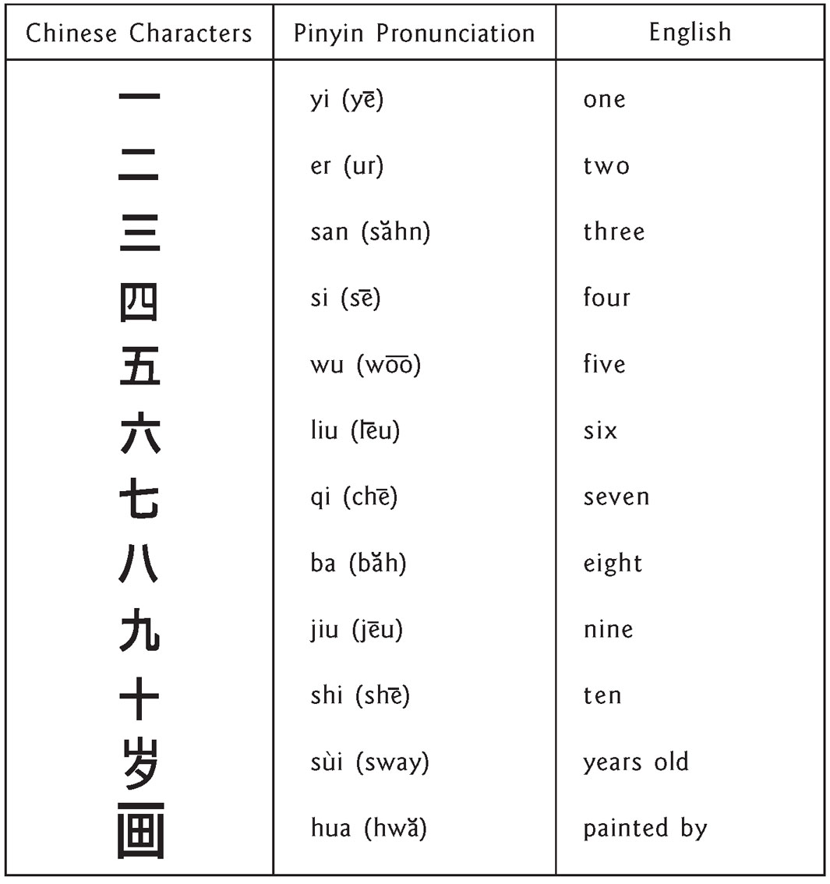
REFERENCE SHEET:
Art Materials
Use this reference sheet and the “Crayola Dream-Makers III Guide” for selecting art materials.
Paper
Choose paper that works well with the materials you are using (such as paint, pencil, crayon, chalk, print-making). Always try the materials out on the paper yourself before working with the children. This allows time to correct any problems. For example, some paper is thin, and crayon tends to rip it. Paper that is shiny, or that has a waxy coating, will not hold paint or chalk. There are several sources for locating art materials, including:
• School art teachers.
• Printers and paper companies, who often have scrap paper to donate. It is okay to use good quality scrap paper that has printing on one side if the printing does not show through to the back. Some of the Chinese children’s pictures are on such recycled paper.
• Art, teacher or office supply stores.
• Mail order art supply catalogs. These are usually the most inexpensive sources for new materials. Your local art teacher can recommend sources. Art magazines often list sources as well.
• Coordinators in intermediate school districts gifted and talented programs.
• Art centers.
Brushes
The shape and type of paintbrush bristles can change the look of a painting. Brushes with soft, long bristles hold more paint and water. This type of brush produces transparent color and long, or flowing, lines. Brushes with stiffer and shorter bristles make sharper and shorter lines.
Paint
Water-based paints, such as tempera, poster paints and watercolors are the easiest to use and to clean up. They generally will cost less than oil or acrylic paints. When applied thickly, they can be used for a bright and bold effect; when used with water, a delicate or transparent effect occurs. Look for paper that will not tear easily or fall apart when wet.
Crayon
Crayon can be used to draw lines, color areas and backgrounds, or in other interesting ways. The children will need to use more pressure to make bold, bright marks with crayons. A thick or tough paper will hold up better than thin paper. Crayons can be used to make lines or to fill in larger areas by removing the paper that is wrapped around the crayon and rubbing the side of the crayon on the paper.
Chalk
Chalk is brilliant and bold, as well as soft and delicate. Using chalk on contrasting colored paper is exciting, because it makes the color seem to “pop off” the paper. The type of paper you use with chalk is important. A heavy-weight paper with a coarse surface makes the chalk stick better and is less likely to tear. Chalk is soft and dusty. This quality makes it easy to blend colors or create shading by rubbing the surface of the drawing with the fingers, a soft cloth or paper towel. Because chalk is dusty, the picture has to be “fixed” or sealed in order to prevent it from smearing after the children are finished. One coat of commercial fixative, or five or six coats of an inexpensive hair spray, will seal the chalk dust in the paper. Fixative can be purchased easily with your other art materials. Safety Note: Inhaling large amounts of fixative and hair spray can be harmful. Do not let your children spray their pictures. You or another adult should spray the pictures outdoors or in a well-ventilated room.
Pens, Pencils and Markers
Pens, pencils and markers allow children to create very detailed, precise drawings. These materials alone make great pictures; however, they can also be used with paints, and with crayons or chalk. (Refer to the Mixed Media section.) When children use pens, pencils and markers, they tend to make smaller and less bright pictures. Larger and bolder art, which can be seen from about 10 feet away, will make a strong local art exhibit. Pencils with softer leads (No.2 or softer) work well. Markers (brush and felt tip markers) work better than ball-point pens. Be sure to use water-based child-safe markers. (Many permanent markers contain solvents that produce unsafe fumes.) Experiment with the drawing tools before introducing them to the children.
Mixed Media
Combining art materials, such as markers and paint, or crayons, glue and chalk, is called mixed media. Try mixed media projects yourself, before introducing them to the children.
REFERENCE SHEET:
Common Problems Encountered When Doing Art Projects With Children
The Child Needs Help With Ideas on What to Draw or Paint
Every child has a wealth of ideas to share. However, you may need to talk with some children one-on-one to help them identify an idea. Ask the child what he or she enjoys doing, and what he or she thinks a Chinese child would like to know about life in Michigan. Remind the child that the Chinese children want to know about his or her favorite hobbies, pets, holidays, family members, school activities, vacations, seasons and lots more.
The Child Is Discouraged About Being Able to Draw or Paint
Tell the child there are lots of ways to draw a horse, a house, a car or a tree. Help the child see the picture in his or her mind before putting it down on paper. Do this by asking him or her to describe the picture or idea to you. Encourage the child to experiment and see what happens. Reassure the child that he or she can do more than one picture.
The Child Finishes and There’s Still Lots of Time Left
Ask the child to tell you about his or her picture. Is the child telling you about ideas or things that are not part of the picture? If so, encourage the child to add these details. Remind the child that most Chinese children can’t speak English, and that his or her picture is like a letter to them. Ask the child if there is anything more he or she would like to say in the picture. If the child says no, ask if he or she would like to do a second picture.
Paper Space Is Not Fully Used
Sometimes empty space can be important to the way a picture looks. For example, study some of the traditional Chinese brush paintings. When the art project was first introduced in Part III: Creating a Painting or Drawing, children should have been told that it is okay to use the whole sheet of paper, and that it is okay to paint and draw to the edges and even off the edges of the paper. This encouragement at the beginning is sufficient. Give the child the freedom now to use the paper space as he or she chooses.
The Child Would Like His or Her Picture to Be Brighter or Bolder
If the child says that he or she would like the picture brighter or bolder, the following techniques may help. If the child is using crayon, pencil, or chalk, ask him or her to press harder or go over the lines again. If the child is painting, sometimes outlining the figures or objects with another color or a dark line will make the picture stand out.
REFERENCE SHEET:
Art Labels
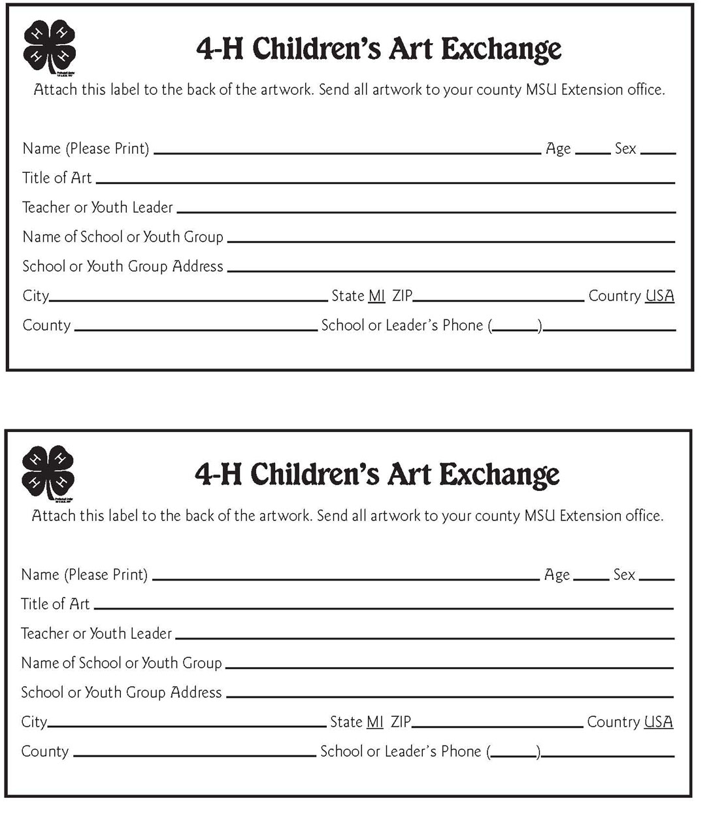
REFERENCE SHEET:
Parent or Guardian Authorization
Dear Parent or Guardian:
Your child has seen several original pictures done by Chinese children as part of the 4-H Children’s Art Exchange with the People’s Republic of China. Each Chinese child’s picture told a story from that child’s point of view about life today in China. Some of the stories were very simple and talked about cats, monkeys or other favorite animals. Other stories were very long and talked about Chinese writing or the Chinese New Year celebration.
Your child has created his or her own picture, too. In fact, children from all over Michigan are creating artwork as part of the 4-H Children’s Art Exchange. Some artwork will be selected to send to China; these pictures become a gift to the people of China and remain there. Please complete the authorization information below to allow your child’s artwork to be considered for inclusion in this program. Thank you.
_ _ _ _ _ _ _ _ _ _ _ _ _ _ _ _ _ _ _ _ _ _ _ _ _ _ _ _ _ _ _ _ _ _ _ _ _ _ _ _ _ _ _ _ _ _ _ _ _ _ _
4-H Children’s Art Exchange Parent/Guardian Authorization
Child’s name (please print): ___________________________________________________
Address: ___________________________________________________________________
County: ______________________________Phone Number: (_____)_____________________
I give my permission to Michigan 4-H Youth Development to send my child’s artwork to Michigan State University for consideration for the 4-H Children’s Art Exchange with China.
If my child’s artwork is selected to be sent to China, I give my permission to Michigan 4-H Youth Development to use my child’s art or any reproduction of it as part of an exhibit, educational material and/or promotion of 4-H. I also give my permission for my child’s photo to accompany his or her artwork to China. The photo may be exhibited with his or her artwork in China. The photo will not be used on the Web, in the media or in 4-H promotional material, unless special permission is granted by me.
I agree that the artwork may be edited, duplicated, distributed, reproduced, broadcast and/or reformatted in any form and manner (including on the Internet) without payment of fees, in perpetuity.
I understand that artwork sent to China becomes a gift to the people of China and remains there.
I understand that my child’s artwork may be displayed on the Michigan 4-H Youth Development web site. Only the child’s first name will be used.
Parent or Guardian’s Signature _____________________________________________________Date __________
Please return this form to:___________________________________________________________by ___________
Teacher or Youth Leader's Name Date Due
REFERENCE SHEET:
4-H Children’s Art Exchange With China Evaluation

Please complete this form at the conclusion of your 4-H Art Exchange With China lesson and send it to ____ ________________ at ____________________________________________. Your participation numbers and feedback will be used to complete a statistical and impact report. Thank you.
Date Completed: ____________ County: ___________________________

Part 1: General Information
Teacher or Youth Group Leader: _______________________________________________________
Name of School or Youth Group: _______________________________________________________
School or Youth Group Address: _______________________________________________________
City: ______________________________________________ State: ________ ZIP: _____________
School or Leader’s Phone: ( ___ ) _____________ E-mail: __________________________________
Total Youth Involved: _______ Males: _______ Females: _______
Number of youth enrolled in 4-H Clubs: Males: _______ Females: _______
How many children at each grade level completed the 4-H Children’s Art Exchange With China program?
K _____ 1st _____ 2nd _____ 3rd _____ 4th _____ 5th _____ 6th _____ Other _____
Ethnicity (optional; combine total number of youth for each ethnicity):

African American/Black |  |  | White
American Indian/Alaskan Native |  |  | White & American Indian/Alaskan Native
Arabic/Middle Eastern/North African |  |  | White & Asian
Asian |  |  | White & Black
Black & Amer. Indian/Alaskan Native |  |  | Other Mixed Heritage__________
Native Hawaiian /Pacific Islander |  |  | Total

Part 2: Using the 4-H Children’s Art Exchange With China Program
- Did your children view the Chinese children’s artwork from a 4-H Children’s Art Exchange teaching kit?  Yes  No
If “yes,” please rate the Chinese children’s art as an educational resource.
❒ Poor  Fair  Good  Excellent
- Did you use the teaching guide from a 4-H Children’s Art Exchange teaching kit with your children?
❒ Yes  No
If “yes,” please rate the teaching guide as an educational resource.
❒ Poor  Fair  Good  Excellent
Please indicate how much you agree or disagree with each of the following statements after participating in this project. Preface each statement with “Because of participation in the 4-H Children’s Art Exchange, my children . . .”

 | Strongly  Disagree | Disagree | Agree | Strongly  Agree
Have increased knowledge of how to talk about art.
Have increased awareness that art communicates ideas, feelings and stories.
Gained new knowledge about China.
Have increased awareness that there are similarities between themselves and Chinese children.
Would like to know more about China and Chinese children.
Learned how to create a "‘visual letter" to a child their own age in China.

- While participating in the 4-H Children’s Art Exchange, did you cross-program with other content areas?  Yes  No
If “yes,” please describe:

- What other resources might be useful to enhance or expand the 4-H Children’s Art Exchange experience for your children?

- When is (are) the best month(s) of the year for you and your children to participate in the 4-H Children’s Art Exchange?

- What is your overall rating of the 4-H Children’s Art Exchange With China Program?
❒ Poor  Fair  Good  Excellent

- Is there anything else you would like to say about this program?

Thank you for completing this form.

REFERENCE SHEET:
4-H Children’s Art Exchange Checklist
Congratulations! You have involved your children in a unique educational experience by using the 4-H Children’s Art Exchange Teaching Kit. Please look over the checklist below before sending your children’s artwork, your evaluation and your kit to your county MSU Extension office. Thank you for your participation. We look forward to your evaluation comments so we can continue to offer this teaching resource to schools and youth groups.

- Review the laminated 4-H Children’s Art Exchange information sheet for the current year included in your kit.
- Each child’s artwork selected to represent your school or youth group has a 4-H Children’s Art Exchange label securely fixed to the back of the art.
- Each child’s artwork selected to represent your school or youth group has a completed Parent or Guardian Authorization form.
- 4-H Children’s Art Exchange Evaluation completed.
- The 4-H Children’s Art Exchange Teaching Kit has been inventoried and all pieces of the kit are accounted for including:
- Chinese Children’s Pictures
- One 4-H Children’s Art Exchange Poster
- One Colored Plastic Pouch with
- Laminated kit inventory
- 4-H Children’s Art Exchange Teaching Guide
- Crayola Dream-Makers III Guide
- Laminated descriptions of the Chinese children’s artwork
- Laminated 4-H Children’s Art Exchange information sheet


MSU is an affirmative-action, equal-opportunity employer. Michigan State University Extension programs and materials are open to all without regard to race, color, national origin, gender, gender identity, religion, age, height, weight, disability, political beliefs, sexual orientation, marital status, family status or veteran status.
Issued in furtherance of MSU Extension work, acts of May 8 and June 30, 1914, in cooperation with the U.S. Department of Agriculture. Thomas G. Coon, Director, MSU Extension, East Lansing, MI 48824.

This information is for educational purposes only. Reference to commercial products or trade names does not imply endorsement by MSU Extension or bias against those not mentioned.

The name “4-H” and the emblem consisting of a four-leaf clover with stem and the “H” on each leaflet are protected under Title 18 U.S.C. 707. Printed on recycled paper.
©2005–09 Michigan State University Board of Trustees.
These materials may be copied for purposes of 4-H programs and other nonprofit educational groups.

